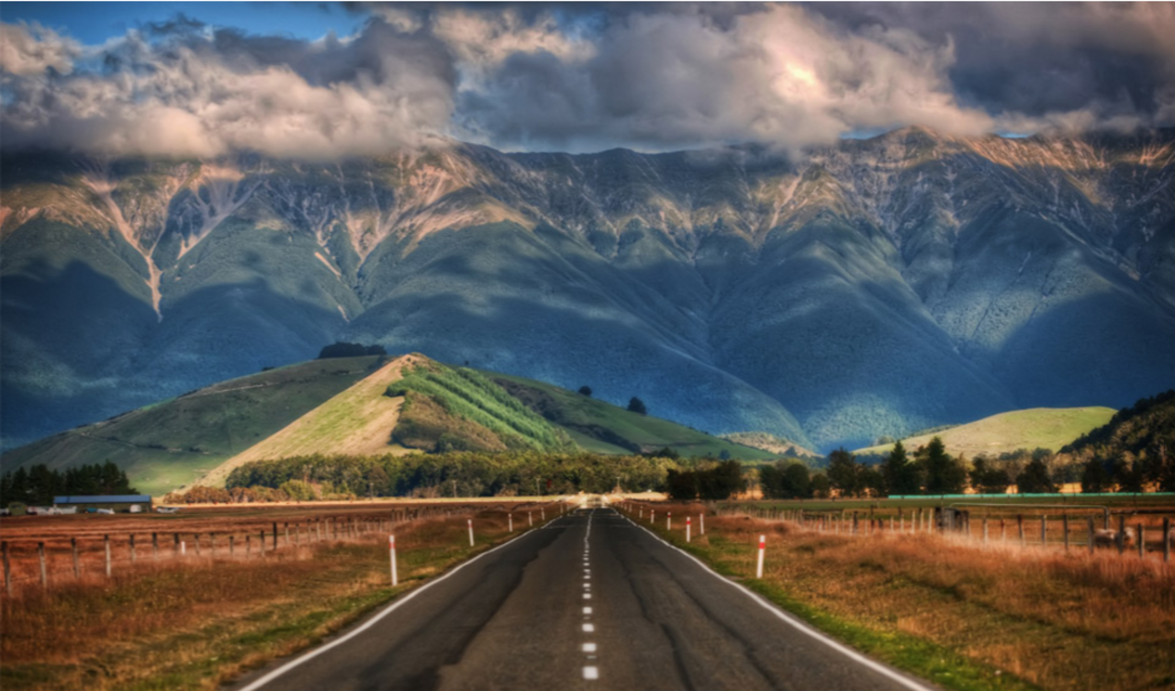
- Summarise what is happening in this picture.
- How would you feel if you were in this picture? Give reasons to support your answer.
- Where is this picture set? What evidence supports this?
- Predict what you think might happen next. Give reasons to support your answer.
- Is this a common or unusual image? How do you know?

