Tuesday 24th March 2020
WALT: Define words from a non-fiction text.

WILF: Children who can… | Pupil | Teacher
Explain words.
Define words.
Find synonyms.
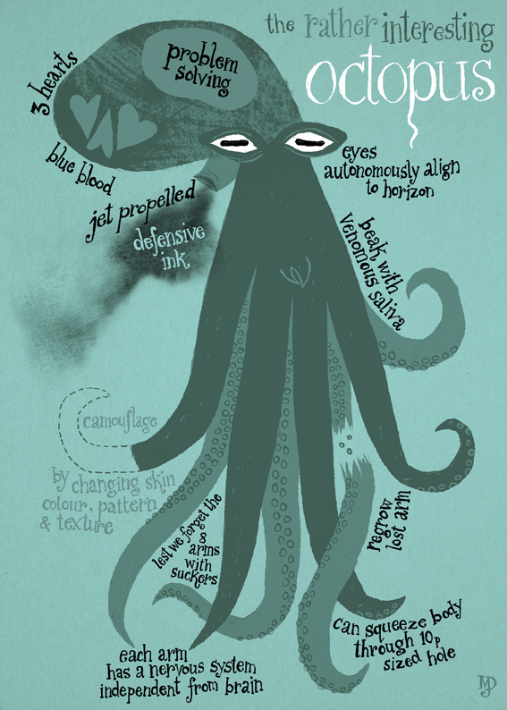
- What does camouflage mean and how does the octopus use it?
- What does independent from the brain mean?
- What is venomous saliva?
- What does defensive ink help the octopus to do?
- Write a synonym for squeeze?

