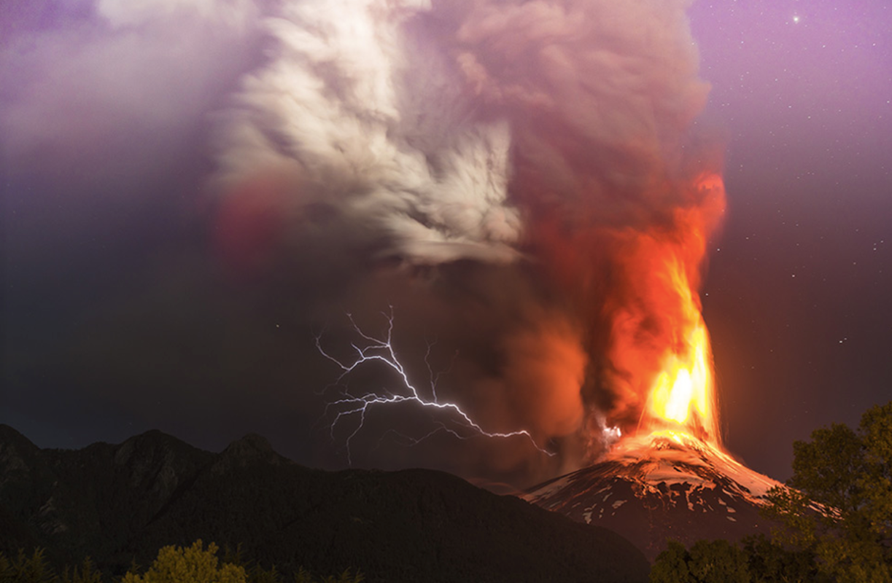
Can you write your own description/short story about the volcanic eruption? Can you include personification and metaphors? Use the image and extract below to help you.

It was the moment they had been dreading for decades: the volcano had finally erupted. The earth shook, as torrents of golden death cascaded over the helpless landscape. Clouds of ash swarmed over the countryside, enveloping everything in their path. Chaos reigned as the beast that had been sleeping for years, now awoken, smote his fury upon the world.
In the distance a flash of silvery lightning licked across the sky: a snake’s forked tongue lashing out in fury to strike its prey. The world was on fire. It was natures turn to take its revenge.

