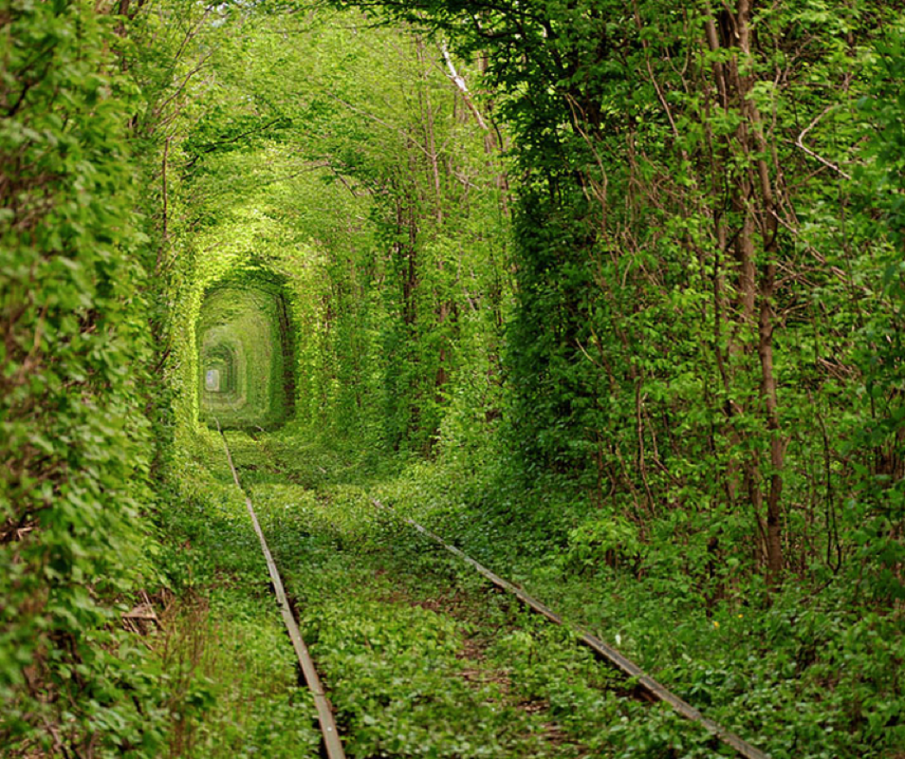
Complete this story using the image to help you.

Motionless, she stood gazing down the never-ending tunnel. The track extended as far as the eye could see, encased by walls of brightest green. The trees that lined the way grew tall, reaching up and over, interlocking their spindly branches like fingers trapping whoever dared to walk this treacherous route. It was like looking down nature’s kaleidoscope.
Where did the path lead? She had dreamt of this moment, but in her dream she couldn’t remember what happened next.
There was only one way to find out; she bravely took a step forward…

