Moon Ladder-Day One.
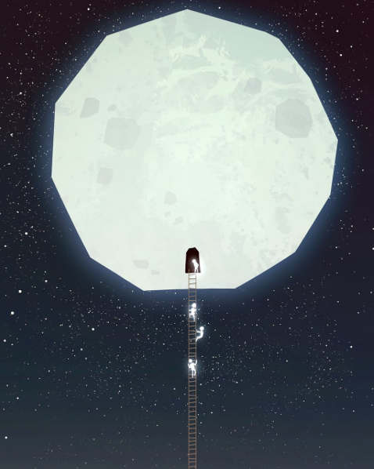
WALT-Write effective sentences for a story.
WILF-
- Descriptive words.
- Direct speech.
- Similes.

The folk who lived on the moon where very secretive…

Describe the people who lived on the moon and what they do there. Remember to use the WILF for your sentence types.

