Moon Ladder-Day Two.
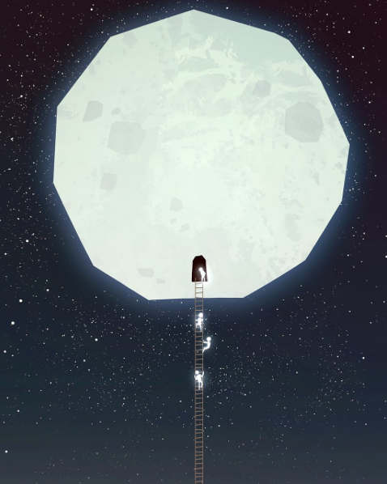
WALT-Write effective sentences for a story.
WILF-
- Describe a setting.
- Alliteration.
- Relative clause.
Inside the moon was beautiful, even more so than the outside…
Explain the setting of the story. Remember to use the WILF for your sentence types.

