Moon Ladder-Day Four.
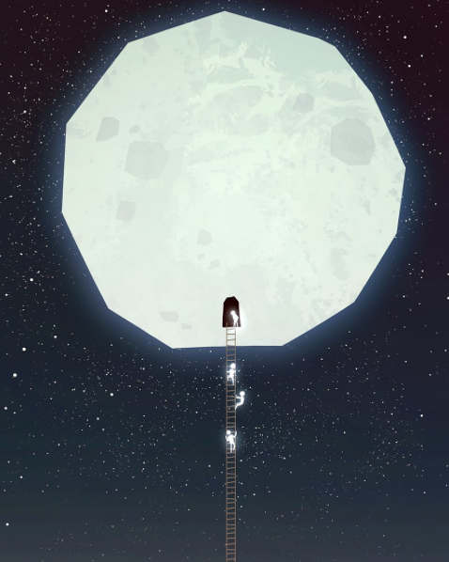
WALT-Write effective sentences for a story.
WILF-
- Parenthesis.
- Pathetic fallacy.
- Short sentences.
The moon people carried out important work for the people of Earth and the moon, but one day something went terribly wrong…
In this chunk you need to describe something that goes wrong, putting the people of Earth and the moon in danger.
Remember to use the WILF for your sentence types.

