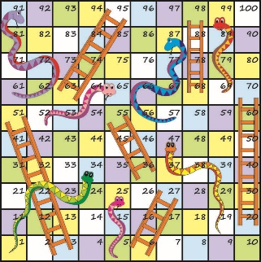
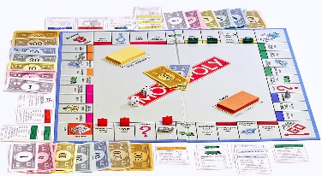
Design and make your own board game

We would like you to design and make your own board game to play with the people in your house.

Your board game could be based on your favourite film, book, TV show or something educational – it can be anything at all!

Please send us photos of your original ideas for your board games – we might need your ideas to help others!

If you have any games at home please take this time to enjoy playing them with your family

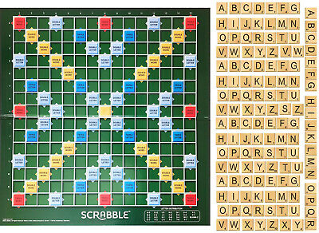
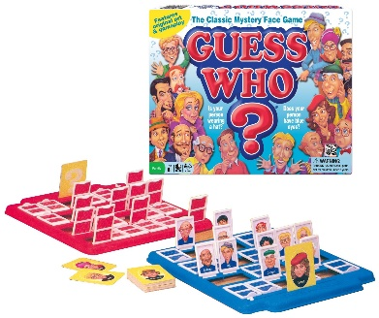
STAY HOME, STAY SAFE!
