Use the image to complete the story.
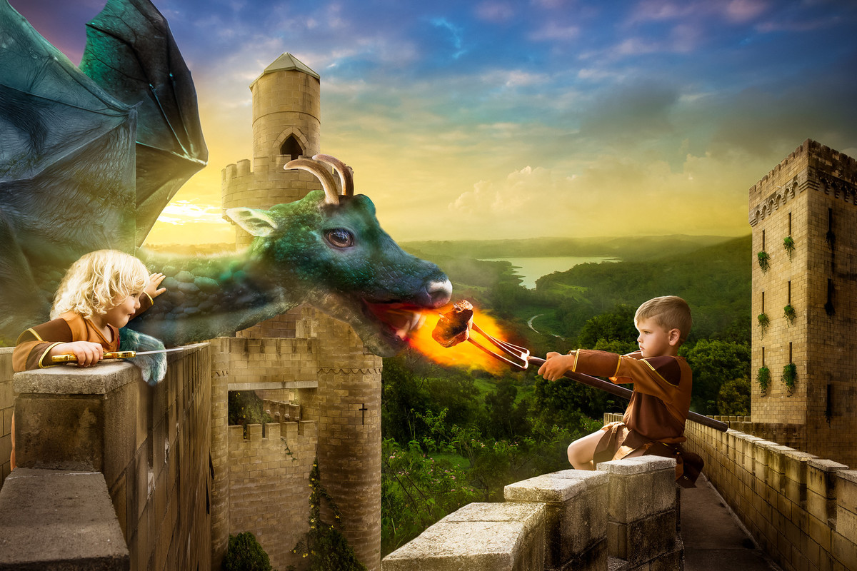

The King had known that the gift he presented to his children on their 5th birthday was dangerous. He was prepared to take the risk of letting them own a pet dragon, however. One day, the twins would rule the kingdom together, and they would need all the help they could get. No-one could deny that a dragon was a powerful ally!
Before that day, though, the children had much work to do. They had to train their dragon!

