Easter Home Learning Bingo
See how many you can complete!

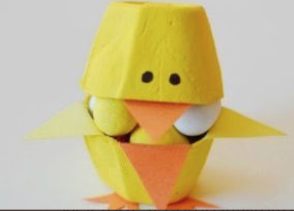  Use an egg box to make an Easter chick | Go for a walk.  What signs of Spring can you see?  Make a tally chart. | Go on a colour hunt around your house.  Can you find 3 red, 2 yellow, 5 green, 4 blue and 1 purple object? | Write a short story about a fluffy spring chicken or the Easter Bunny. | 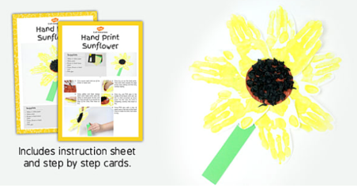  Make a handprint sunflower
How many egg-shaped objects can you find in your house?  Add them all up! Can you write a number sentence? | Make a teddy bear picnic for your garden or living room. | Make a thank you card for the NHS & keyworkers, or paint a rainbow for your window | Draw a chicken. Add some eggs to the nest. A few of them hatch. How many are left?  __ - __ = ? | 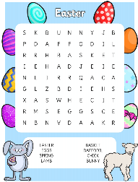  Make an Easter word search and ask a friend to complete it!
Write a message for a neighbour or family member and post it. | Find an odd sock and make a sock puppet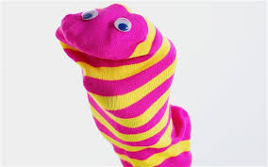 | Draw a Spring picture and write a caption!  Daffodils, lambs, bunnies, chicks, sunshine, flowers. | How many things in your home can you find that start with these letters  – E A S T E R –  write a list! | The Easter Bunny has 10 chocolate eggs. He has some in one basket & the rest in another. What combinations could he have? __ + __ = 10
Design the ultimate Easter Egg.  What would it have on it or inside it? Give your design a name. | Create a one more/one less board game! Write numbers on paper and roll a dice. What is one more and one less? | Paint an egg like your favourite book character.  Can you tell the story to someone at home? | 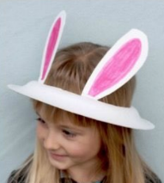  Make an Easter bonnet from a paper plate | Make a den or a fort and read a story in there!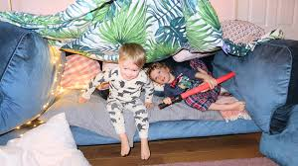

Screen free Maths English Crafts

