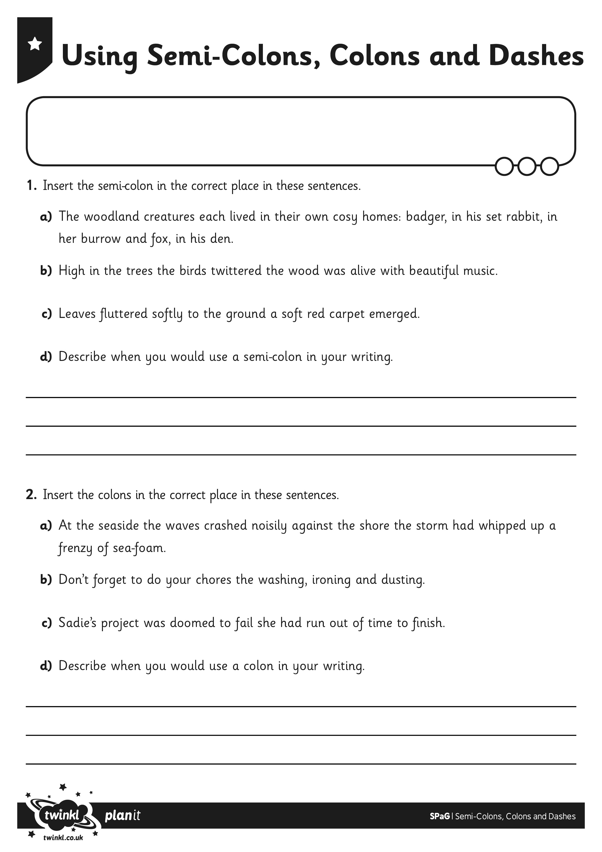
I can identify where to use semi-colons, colons and dashes.
I can write my own sentences using semi-colons, colons and dashes.
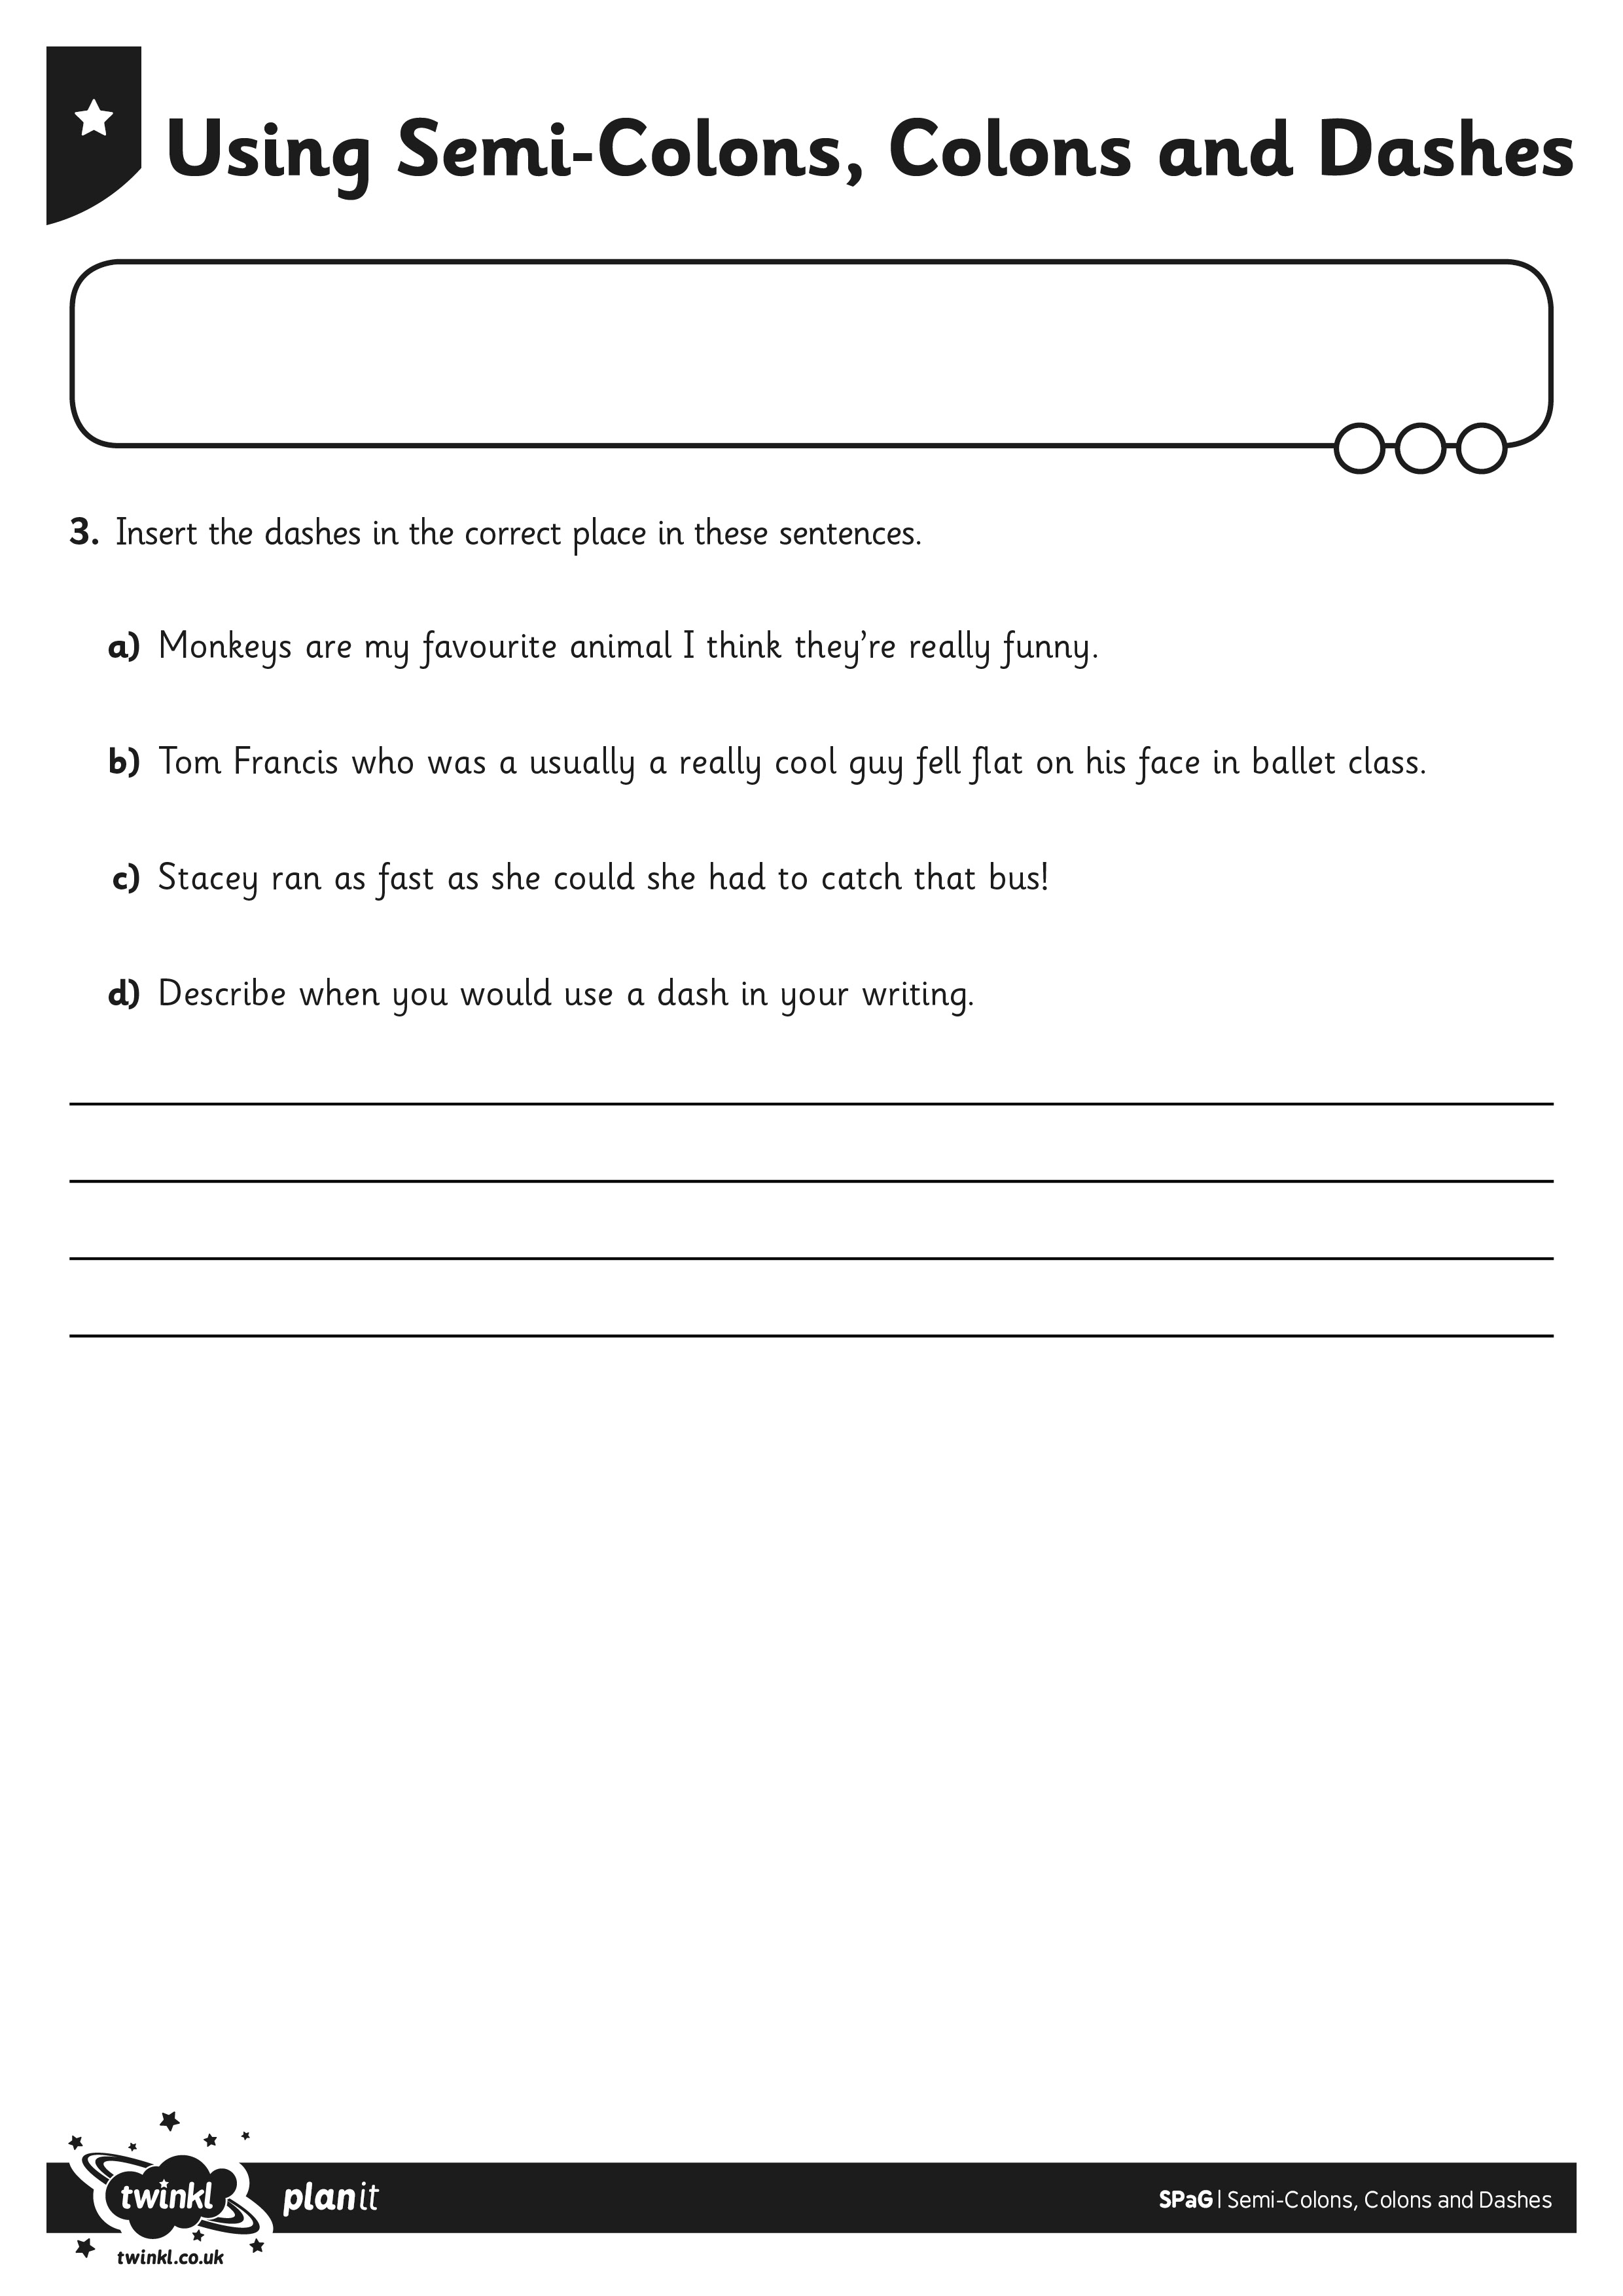
I can identify where to use semi-colons, colons and dashes.
I can write my own sentences using semi-colons, colons and dashes.

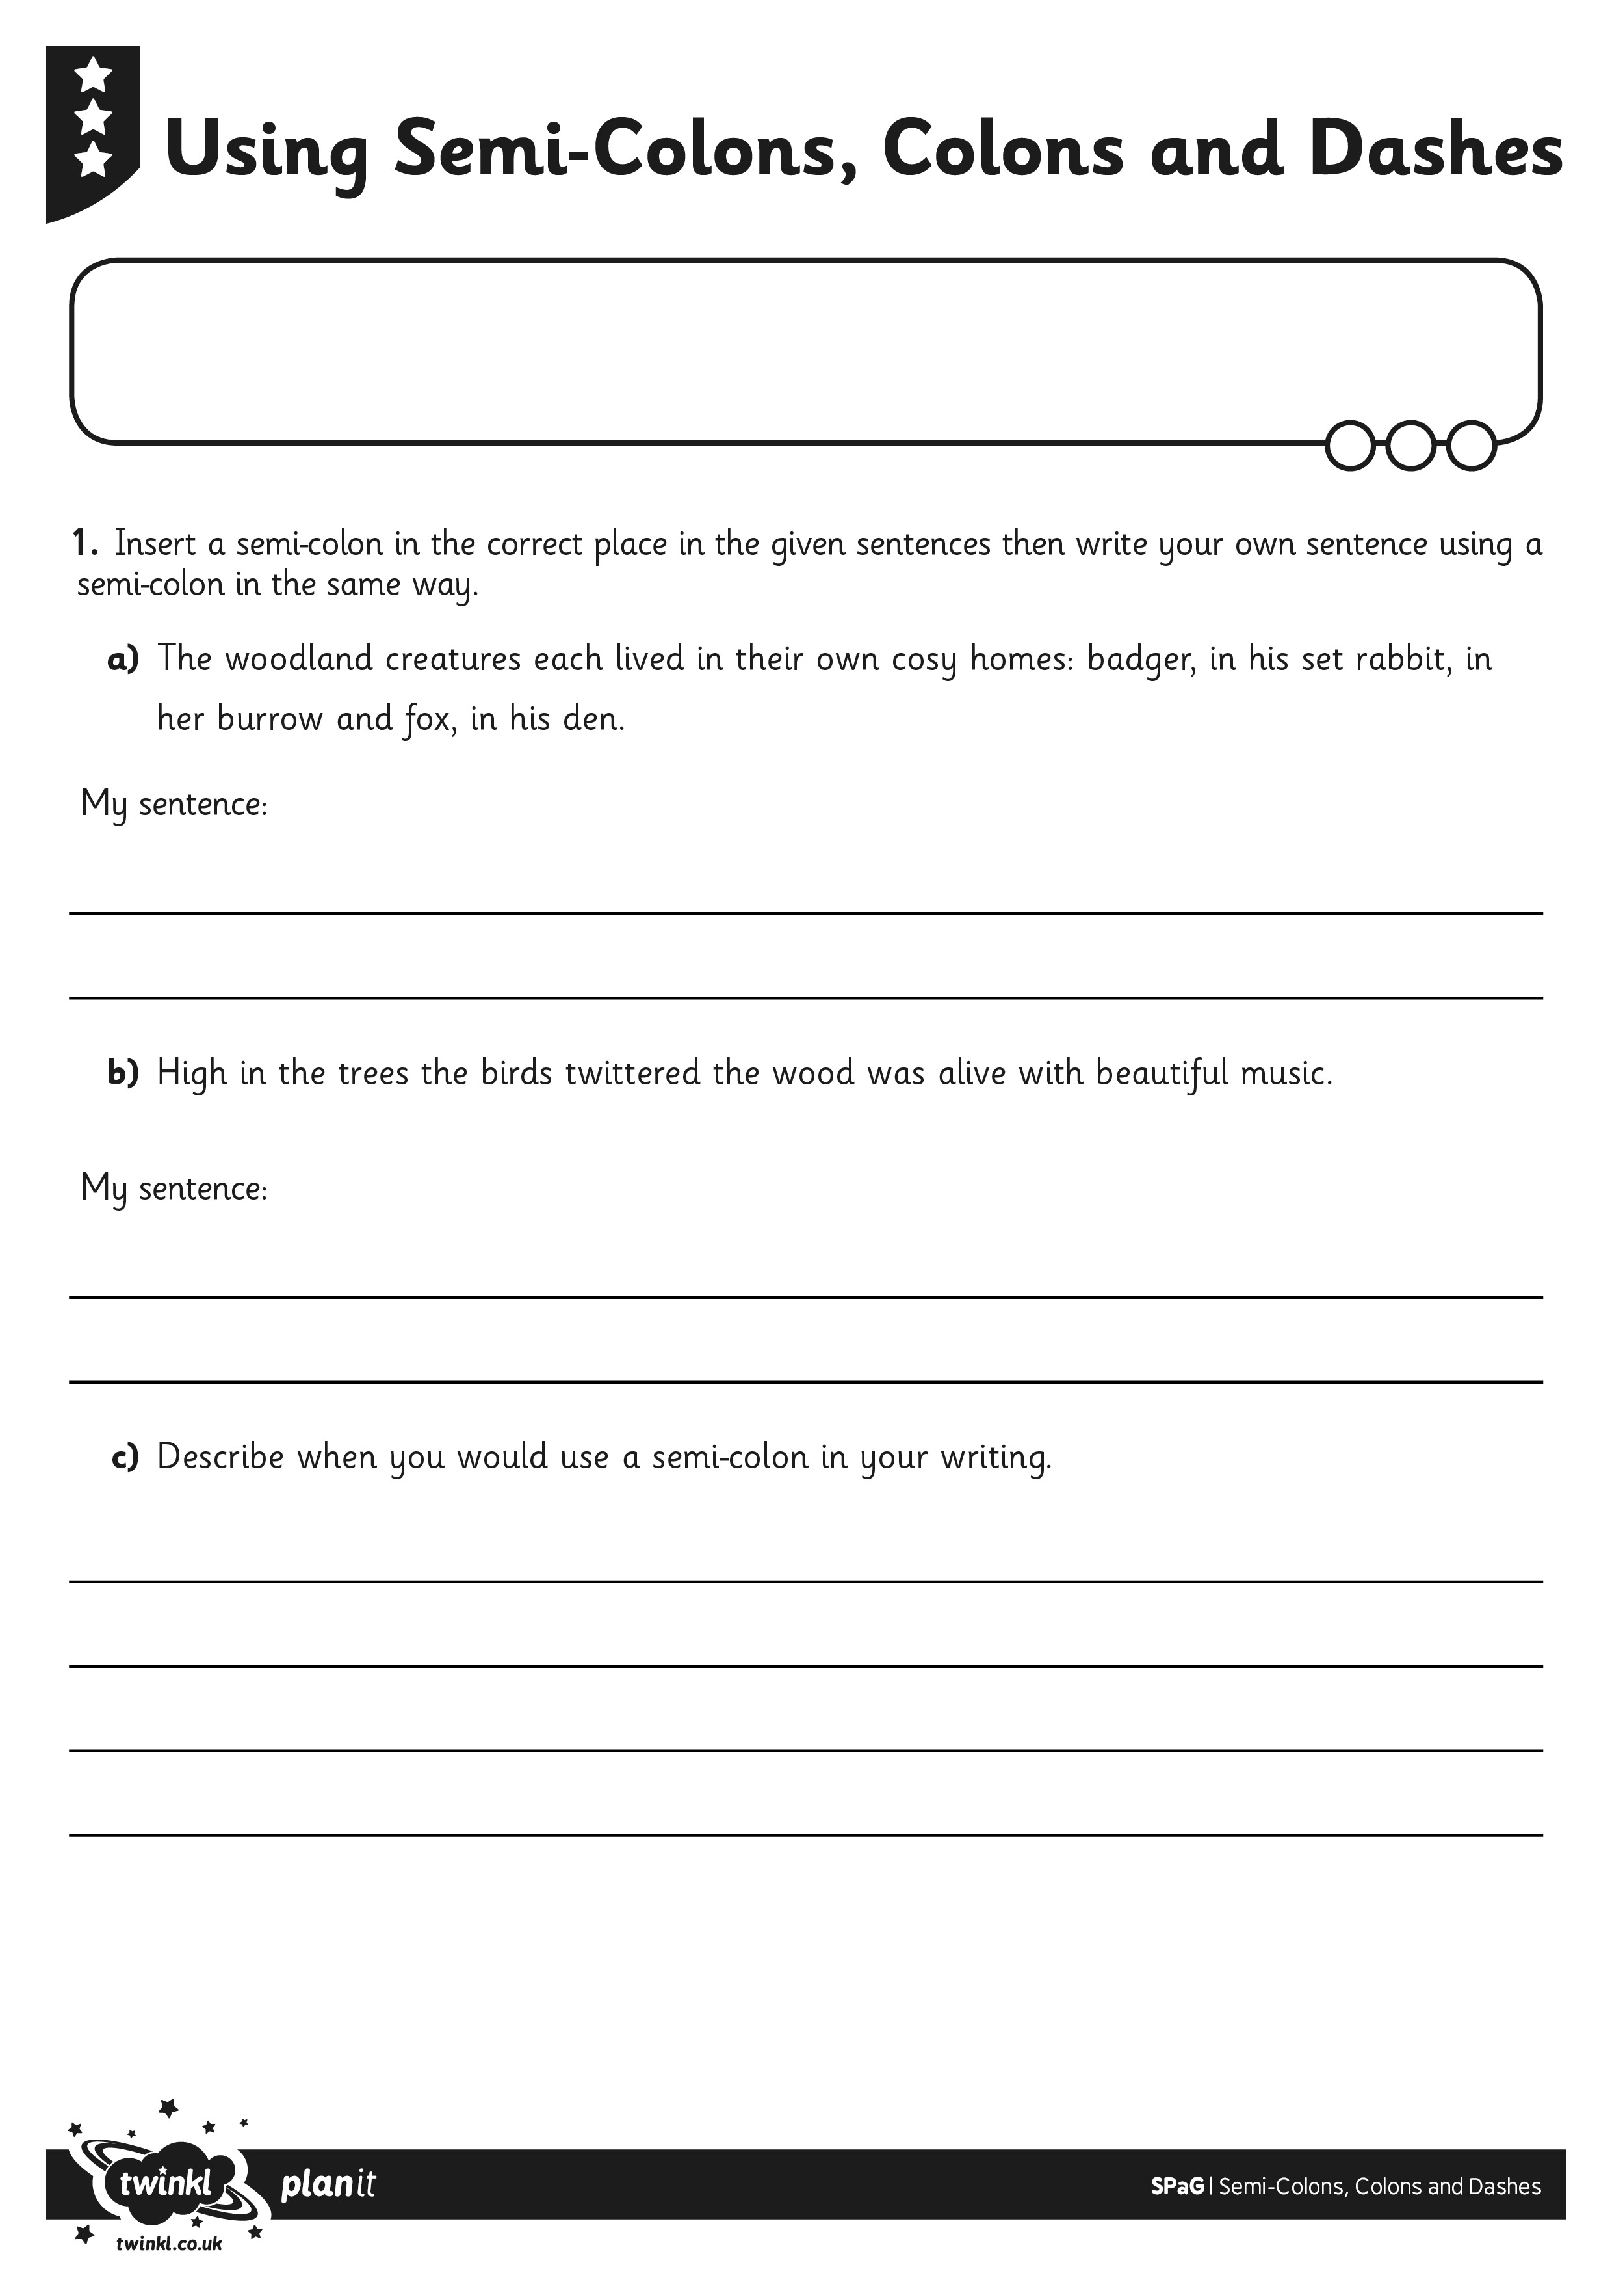
I can identify where to use semi-colons, colons and dashes.
I can write my own sentences using semi-colons, colons and dashes.

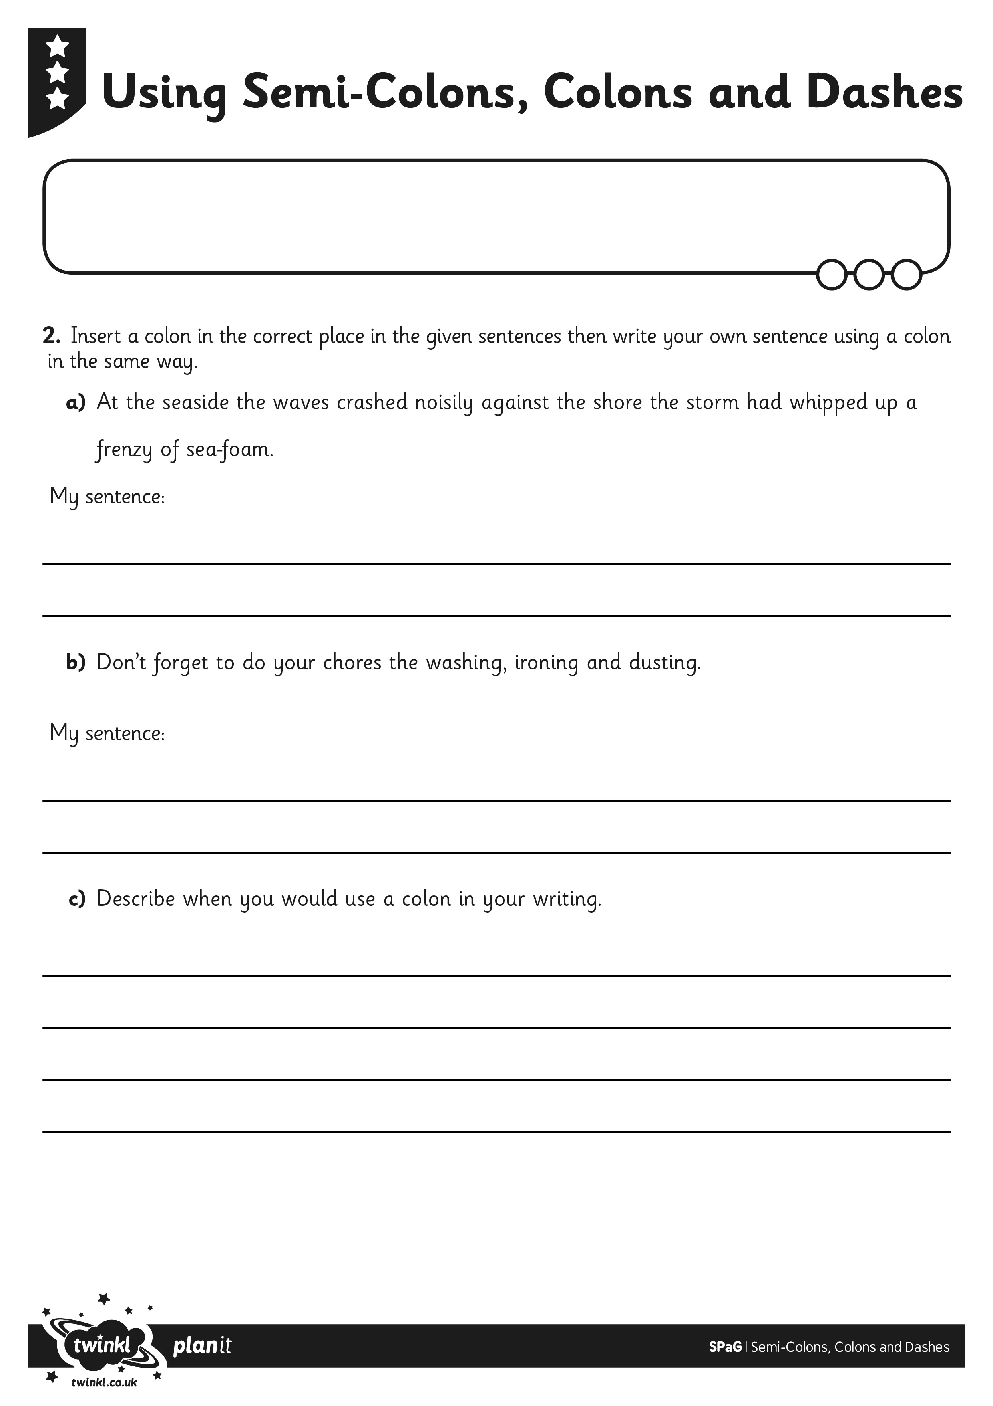
I can identify where to use semi-colons, colons and dashes.
I can write my own sentences using semi-colons, colons and dashes.

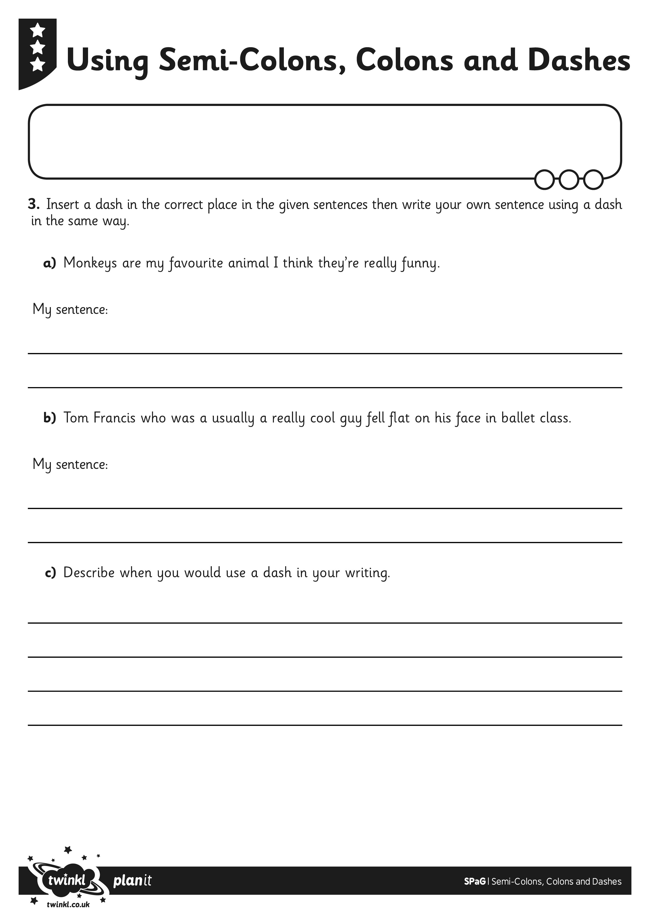
I can identify where to use semi-colons, colons and dashes.
I can write my own sentences using semi-colons, colons and dashes.

