Flashback 1
What can you remember from previous learning? Give yourself 5 minutes to answer the questions.
Don’t forget to read the time on the clock as well.

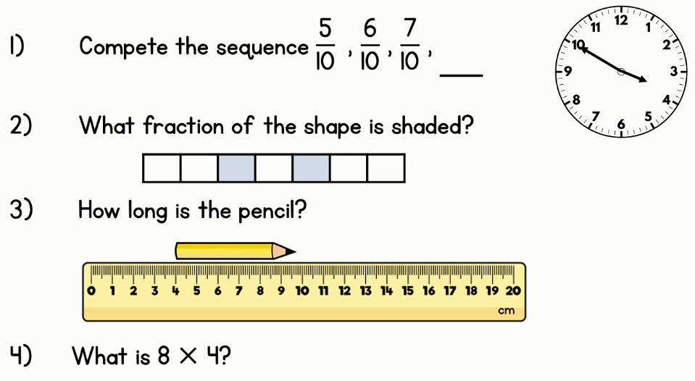

Answers:
The time is 10 minutes to 4.
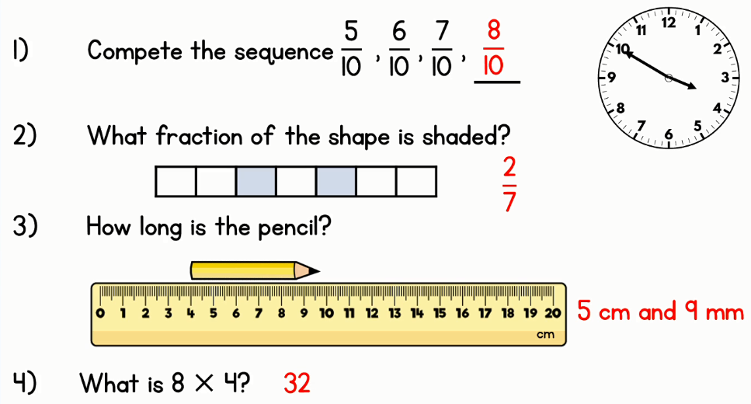
Flashback 2
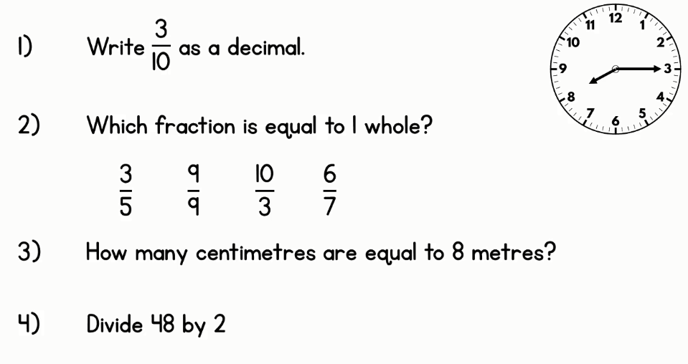

Answers:
The time is quarter past 8.
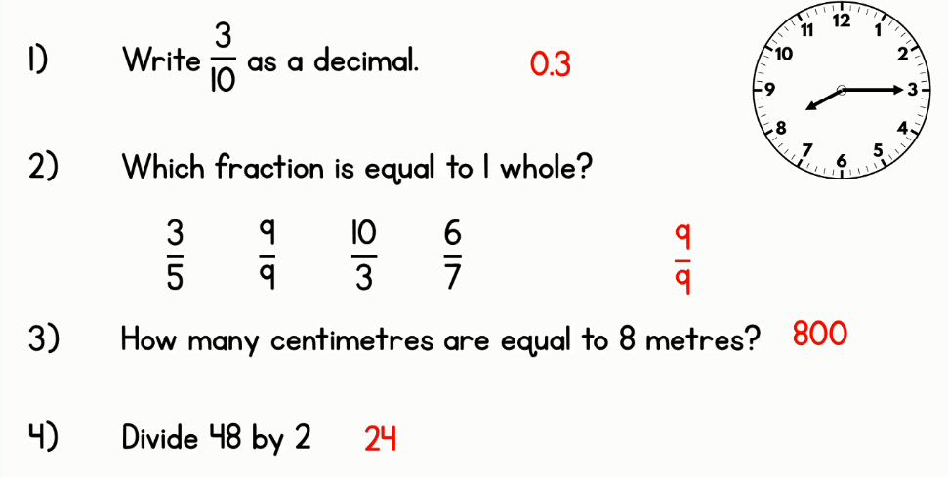

Flashback 3
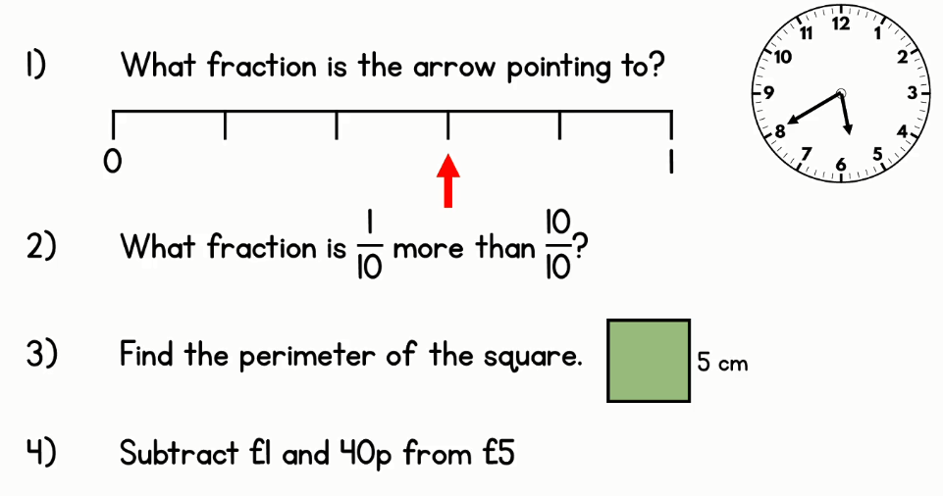

Answers:
The time is 20 minutes to 6.
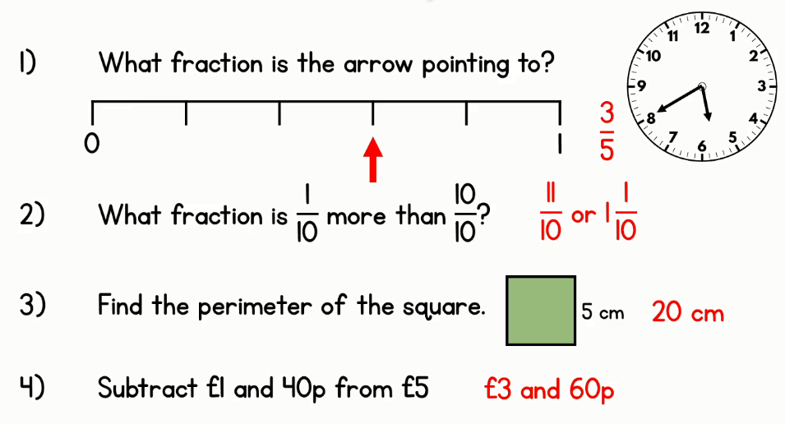

Flashback 4
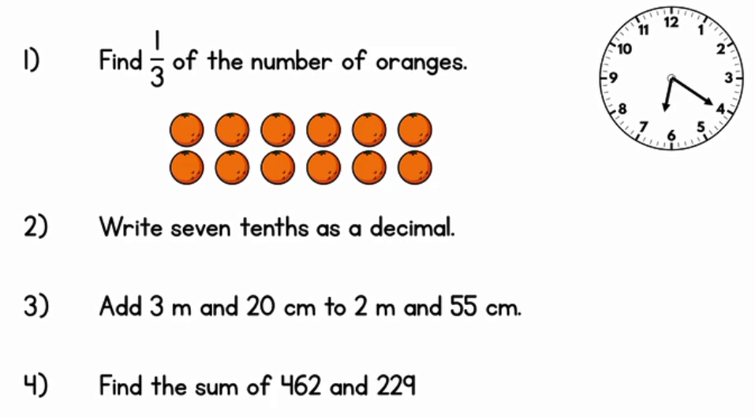

Answers:
The time is 20 minutes past 6.
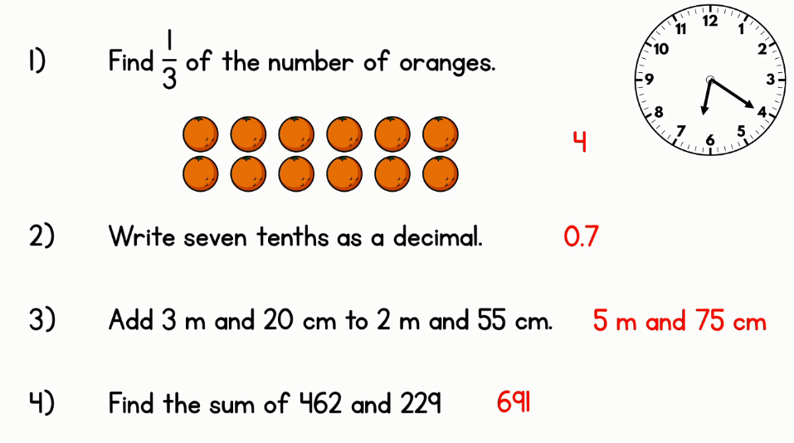

Flashback 5
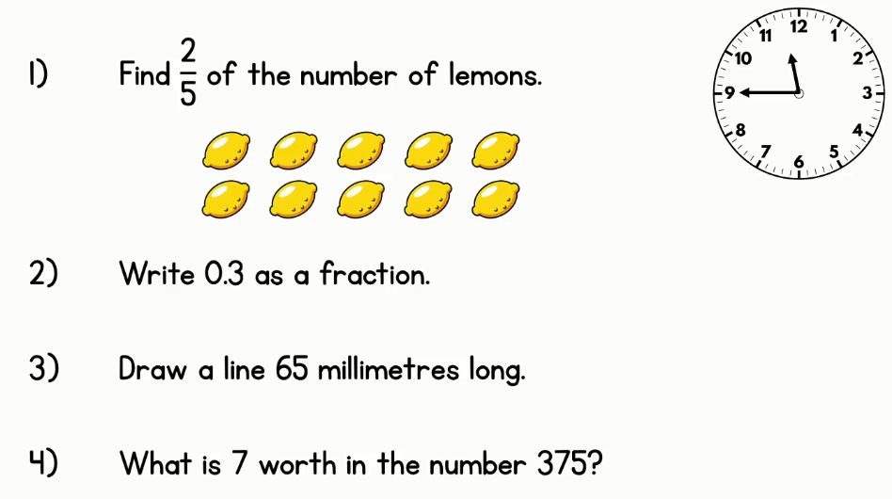

Answers:
The time is quarter to 12.
