Please read and support if you are able to.
We have some wonderful little artists, I'm sure they could all help to fill the walls with colour.

Rainbows for Nightingale.

NHS Nightingale are looking for pictures and messages of Hope drawn by children to decorate the bare walls.
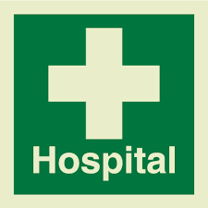

Hello all,

Firstly THANK YOU for your support in this. The more pictures we get the better. These will be put up on the walls in the Nightingale Hospital to brighten the place up. At this awful time let’s bring some colour and hope to both patients and staff.

Please ensure that pictures are A4 so they can be laminated for infection control purposes. If you can laminate them before sending to your regional hub PLEASE do! This saves a lot of work for those who are giving up time to do this. Feel free to draw as many as you like there are no restrictions on sharing the love! Also if you’d like to write a message of hope or get well wishes please feel free to!

Whichever region you live in can you please send your pictures to the address that has been assigned to your region (I know not all addresses are within your region but we’ve had to divide it up the best we can with the volunteers we’ve got). This helps to share the load between those who have volunteered.

When you’ve posted to your regional hub - they will then be lovingly collected and once there’s enough will be sent on to someone who will deliver them to the Nightingale Hospital.

Finally on a health and safety point - please adhere to all government guidelines and adhere to safe self distancing measures. Always wash or gel hands after handling post etc.

All pictures should be addressed to “Rainbows for Nightingale”

North West
Rainbows for Nightingale
36 Kerry Close
Barwell
Leicestershire
LE9 8HT

