Usain Bolt
Do you know who the world’s fastest man is? The world of athletics has never been the same since Usain Bolt began to entertain us while dominating the sprinting events at the Olympics.
Growing Up.
Usain Saint Leo Bolt was born on the 21st of August 1986 in a small town in the sunny country of Jamaica. He is a World and Olympic champion sprinter and many people believe he is the fastest person ever which has earned him the nickname ‘Lightning Bolt’!
Usain Bolt grew up with his parents and his brother and his sister. His parents ran a small grocery store. Bolt’s family attended the local Catholic Church and even today he still makes the sign of the cross before all of his major events. As a boy all of Bolt’s free time was spent playing cricket and football in the street with his brother. He was sports mad! Bolt attended Waldensia Primary where he first began to show his skill for running in the primary-schools' meeting for his area. By the age of twelve, Bolt had become the school's fastest runner over 100 metres. Usain’s father said ‘His speed is because of Yam Power!’ (Yams are an important part of the Jamaican diet.)

School life.
Bolt went to William Knibb Memorial High School. He enjoyed playing team sports but he was such a fast sprinter his teachers encouraged him to try track and field events. His first successes were;
- 2001 a silver medal in the high school championships.
- 2002 a gold medal in the World Junior Championships in Kingston.
- 2007 two silver medals at the World Championship in Osaka, Japan
Olympic success.
Eventually Bolt got his big chance in 2007. He broke the Jamaican 200-metre record and earned two silver medals. Bolt decided he really could achieve success as a sprinter. He qualified for the 2008 Summer Olympics and went on to win. Later Usain Bolt went on to defend all of his Olympic gold medals during the 2012 Summer Olympic Games. This included beating his own record for the 100metres, running it this time, in 9.63 seconds! Bolt is the first man to win both the 100 and 200 metres in consecutive Olympic Games. He is also the first man in history to set three world records in a single Olympic Games competition!
Other interests.
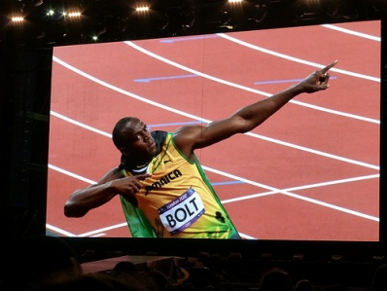
Despite his dedication to running, Bolt still enjoys cricket and football and sometimes talks about taking up one of these sports when he retires from running. He is a big fan of Manchester United. Bolt’s other interests include music and video games. Whatever the future holds for Usain Bolt, you can bet it won’t be boring. He is, in his own words, ‘a living legend’ and with him anything could happen!

