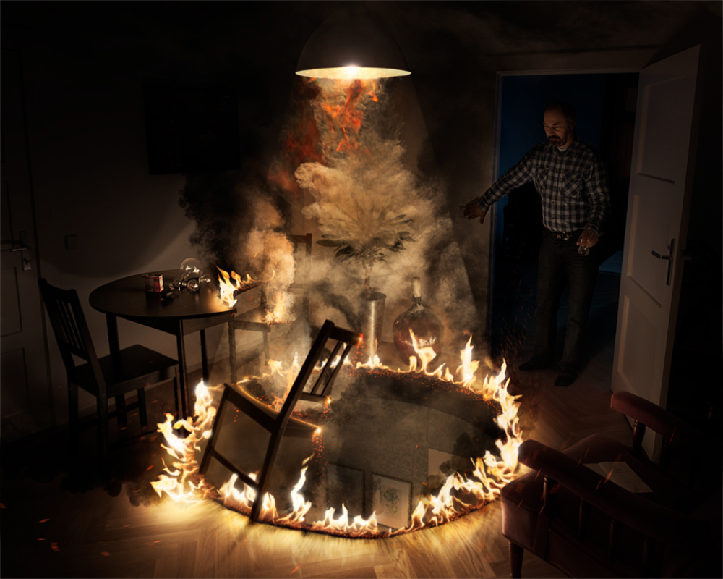
- Summarise what is happening in this picture.
- How do you think the man is feeling? Give reasons to support your answer.
- Where is this picture set? What evidence supports this?
- Predict what you think might happen next. Give reasons to support your answer.
- Do you think this was an accident or done on purpose? Give evidence to support your answer.

