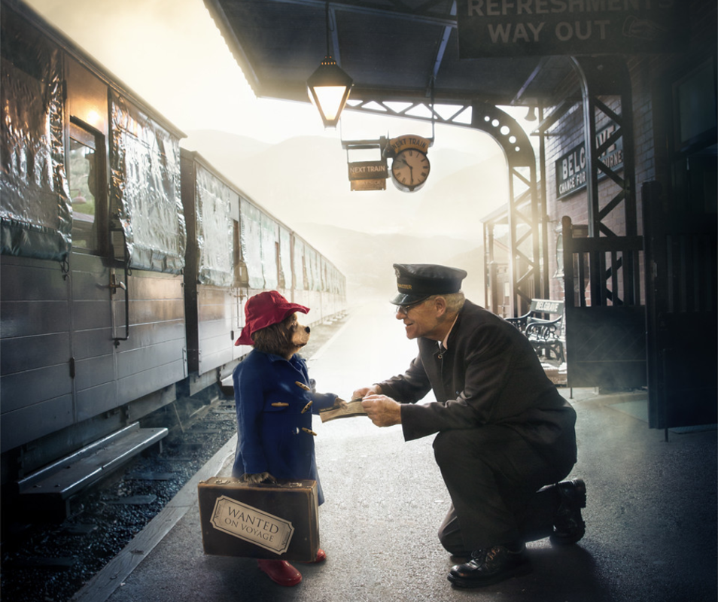
- Summarise what is happening in this picture.
- Who do you think the old man is? Why?
- What do you think the man is doing? Give evidence to support your answer?
- Where is this picture set? What evidence supports this?
- Predict what you think might happen next. Give reasons to support your answer.

