Plastic Pollution

What’s the problem with plastic?

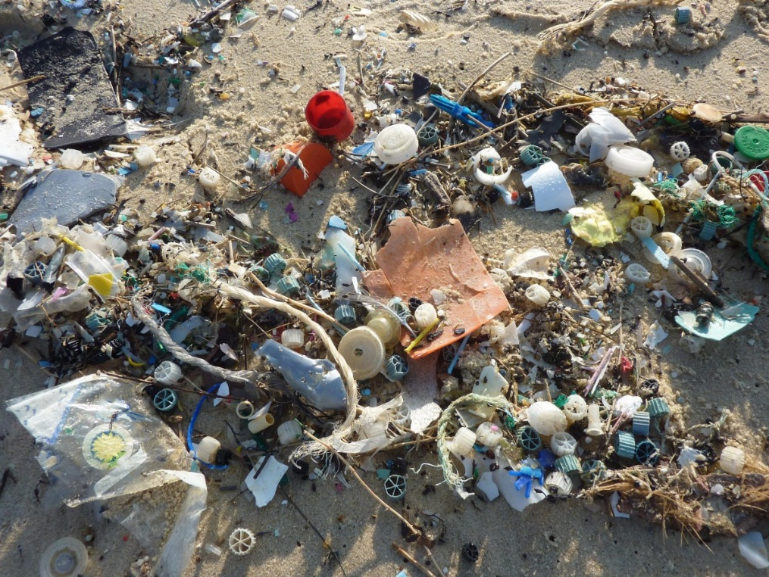
It is an unfortunate fact that plastic can’t be digested easily by the Earth. Our reliance on disposable plastic packaging for a great many things we buy has led to serious environmental problems. For example, experts predict that, by 2050, there will be more plastic in the oceans than fish. With 8 million pieces of plastic entering the oceans every day, we are creating a problem for future generations as well as a problem today.

The increasing amount of plastic in the oceans is creating real problems for the creatures who live in the sea. Wildlife such as dolphins, seals and seabirds often eat plastic, mistaking it for food. Studies carried out on dead sea creatures has revealed plastic bags caught up in the intestines and stomachs of sea creatures, which would have caused them pain when alive and may have caused or contributed to their deaths.

The plastic problem isn’t just limited to sea life: it’s a problem for people too. Latest statistics show that 1 in 3 of all fish consumed by humans contains plastic. The chemicals absorbed by plastic in the ocean have been linked to cancer and other serious illnesses. Added to this, marine life play a key role in producing the oxygen that we breathe, so we should all be very concerned about maintaining healthy oceans.

Is plastic pollution only found in the oceans?

The sad fact is that this would be devastating enough, but it is also only part of the problem. As well as affecting oceans, plastic causes harm to land. The majority of single-use plastics are not recycled, and 79% of all plastics end up as waste in landfill sites. Chlorinated plastic leaks harmful chemicals into the soil, which can then get into water systems and cause harm to the species which drink the water. The breakdown of biodegradable plastics also releases methane, a greenhouse gas which is a major contributor to global warming.

In 2017, a study of tap water around the world found that 83% of tap water contained pollutants from plastic. One of these is the chemical BPA, which can cause fertility problems as well as preventing sexual maturation in humans.

What is being done about the harm caused by plastics?

There has been an effort to reduce and control the amount of plastic being used. For example, many supermarkets are now charging their customers for plastic bags; many coffee shops and restaurants are banning plastic straws; many campaigns have been launched to replace plastic with reusable or biodegradable materials. Recycling has become a common practice, although out of the 8.3 billion tons of plastic that have been produced since the 1950s, only 9% has been recycled.

As well as this, there is a lot of important research into developing biodegradable plastic, such as plastic made from seaweed, corn or sugarcane. Seaweed is especially promising as an alternative to traditional plastics, as seaweed absorbs carbon dioxide and helps to regulate the acidity levels in the ocean.

What is the next step?

The next step is to put pressure on the large corporations to change their behaviour. For example, drinks companies like Coca Cola and Starbucks produce over 500 billion single-use plastic cups, bottles and straws every year. This is not a sustainable amount of plastic to be sending into landfill and ultimately the oceans. However, corporations will only change if there is an incentive to change; in other words, they will only change if they are forced to by either law or if they think it will be better for their business.

Another important next step is to continue the development of sustainable plastics and alternatives to plastic. It is especially important to find solutions to the plastic problem which don’t contribute to carbon emission, chemical pollution or other environmentally harmful practices.

Yet another incredibly important next step is to increase the amount and effectiveness of recycling programmes and investing in the infrastructure of recycling. Since only 9% of plastics have been recycled since 1950, it’s important to find a way of ensuring that more plastic gets recycled rather than ending up in the oceans.

All of the above are important steps that need to be taken in order to secure a safer and cleaner future for the planet and everyone living on it.

You can play your part by not buying single-use plastics wherever possible. For example, you can buy a reusable cup to use at restaurants and coffee shops, and you can contact your favourite brands on social media to tell them that you want them to reduce their plastic production.

The challenge presented by plastics is complex, but we can all play a part in tackling it.

