Sound poems
For English this week, you will be writing a poem. The focus for your poem this week, will be sounds. It is important that you make sure your poem uses lots of words which focus on a range of sounds. Look at the examples below to help you write your poem.
Remember to include the following in your poem:
- Relevant punctuation (Full stops, Capital letters, Commas, Questions marks etc.)
- Title
- Correct layout
Once you have written your poem, practise performing it in front of someone at home. Rehearse it a few times and think about how you can make your poem even more exciting whilst you perform it.
Remember to send videos and pictures to your teachers on Dojo for effort marks!

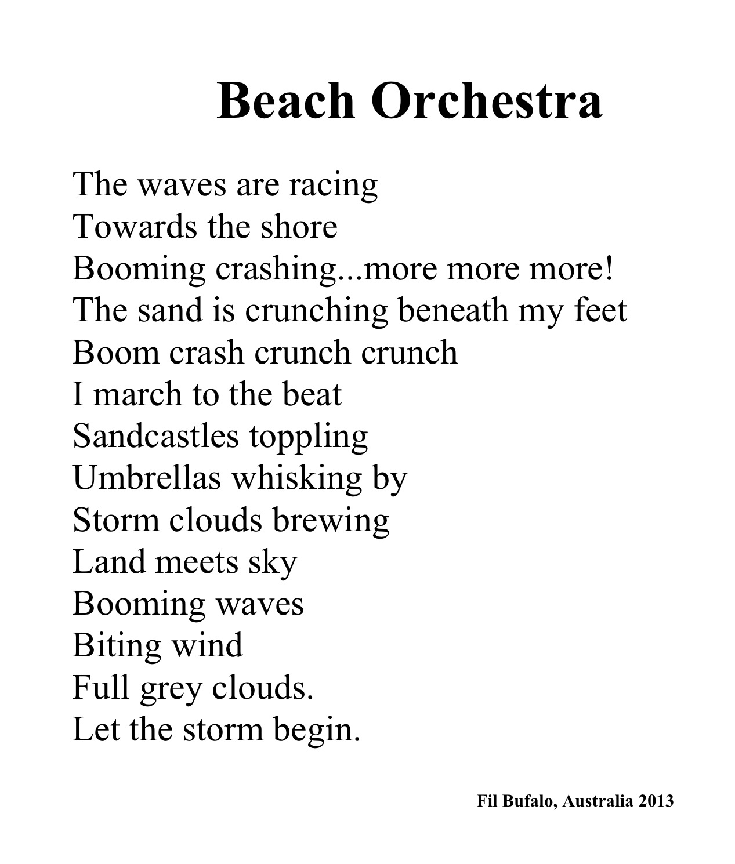

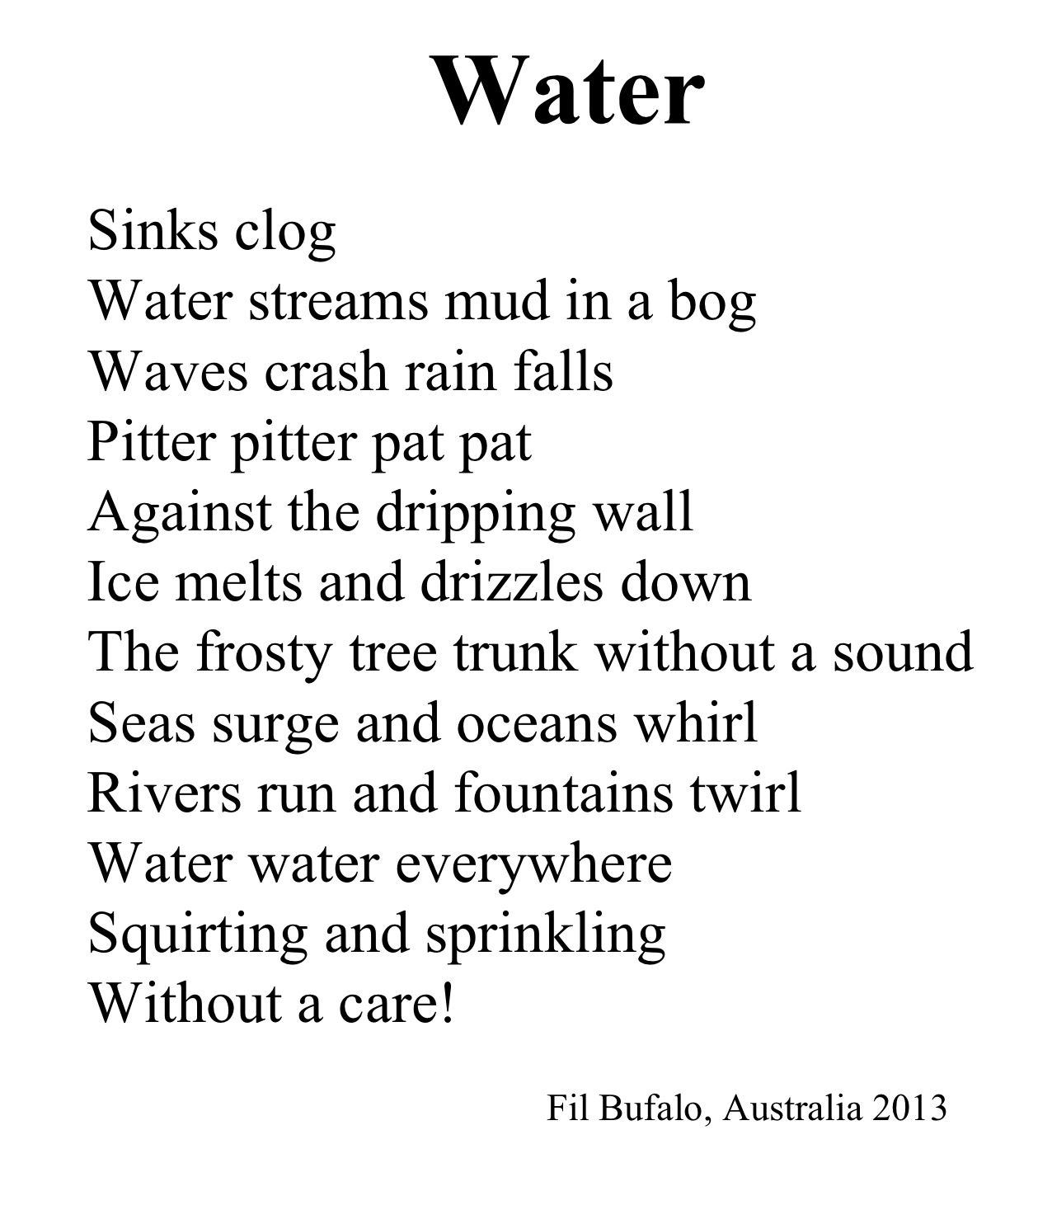

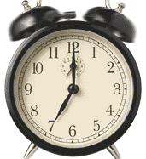
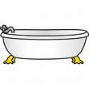
The Sound Collector
A stranger came this morning
Dressed all in black and grey
Put every sound into a bag
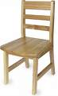
And carried them away
The whistling of the kettle
The turning of the lock
The purring of the kitten
The ticking of the clock

The popping of the toaster
The crunching of the flakes
When you spread the marmalade
The scraping noise it makes
The hissing of the frying-pan
The ticking of the grill
The bubbling of the bathtub
As it starts to fill
The drumming of the raindrops
On the window-pane
When you do the washing-up
The gurgle of the drain
The crying of the baby
The squeaking of the chair
The swishing of the curtain
The creaking of the stair
A stranger called this morning
He didn’t leave his name
Left us only silence
Life will never be the same.

by Roger McGough

