Use the image to complete the story.
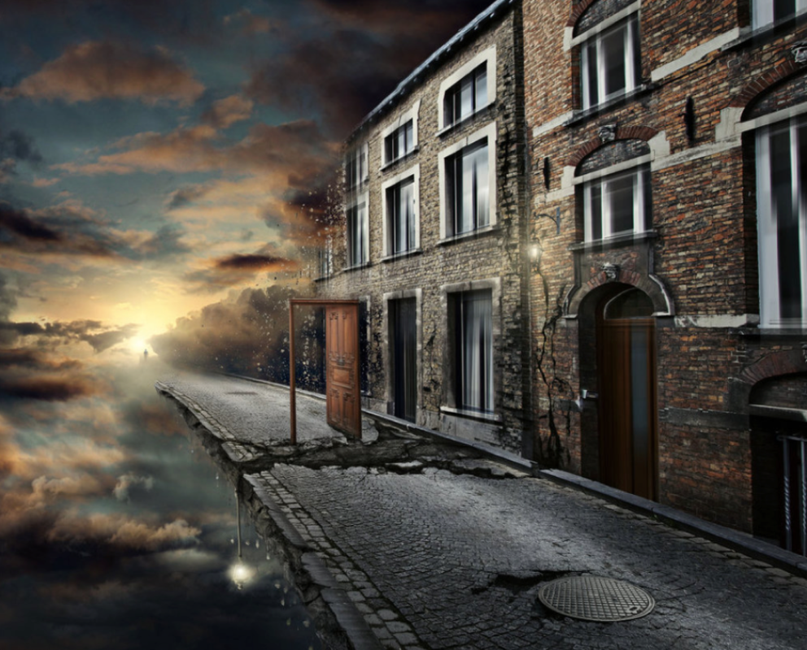

Piece by piece, the street was disappearing.
In the distance a portal shone, sending soft, golden beams of light out across the evening sky. As the light kissed the clouds they blushed, becoming pink illuminations that stood and watched the street below like nosey spectators.
All that was now left of the street was the door. It was still open. There was still time. The figure in the distance began to run, but was he too late?

