Use the image to complete the story.
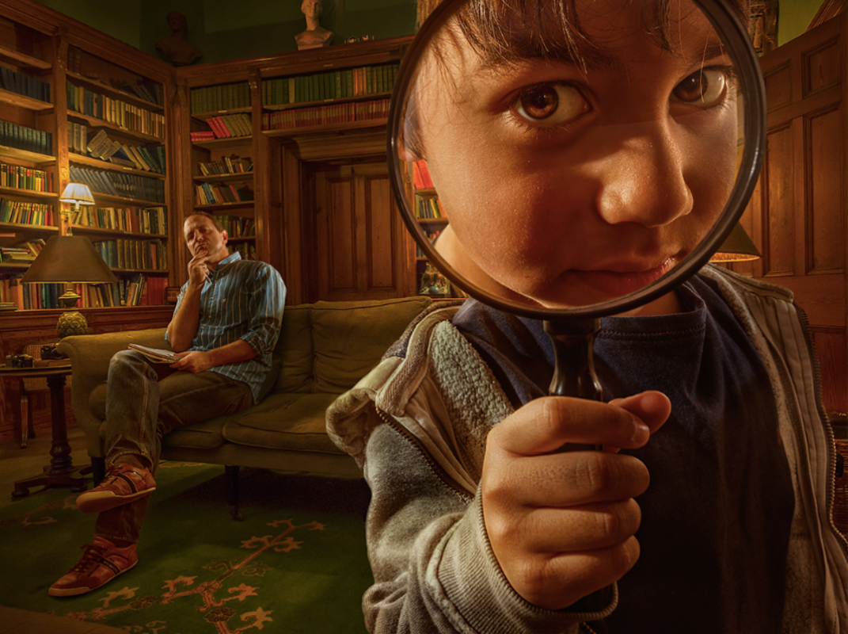

It had been three days since it had gone missing. One minute he had held it in his hand, the next it had vanished. How could it just have disappeared? It had been right in front of his eyes!
He had been warned about what would happen if he lost it. His mission had been to guard the key with his life, ever since they visited him last summer.
Adam had always had a detective’s instinct. They had told him as much. He had been chosen because he had certain skills, and he would need them more than ever now.
Only one clue had seemingly been left, which was sat on the living room table.
Holding the magnifying glass up to his eye, Adam began to investigate…

