Learning Project WEEK 7- Celebrations
Age Range: EYFS
Weekly Maths Tasks (Aim to do 1 per day) | Weekly Reading Tasks (Aim to do 1 per day)
- Watch a Numberblocks clip each day at: BBC or CBeebies. Use this guide here to give you ideas on what to do with your children whilst watching an episode.  - Working on Numbots - your child will have an individual login to access this.  - Play this game to practise counting, ordering and matching numbers to 10.  - Practise counting up to 20. This can be done through playing hide and seek, singing number songs, chanting, board games etc.  - Listen to a number song from the CBeebies website. After listening to them, watch again and sing along if you can. Talk about the maths you can see in the video clip.  - Make a selection of birthday cards with numerals on the front. Can your child count out birthday candles (if you have them available) or objects to match the amount? Can they order the numerals from the smallest amount to the largest? | - Read a variety of books at home. Favourites can be repeated. Hearing the patterns of language in a story will support your child’s language development.  - Reception age children: Children to read to parents daily. Visit Oxford Owl for free eBooks that link to your child’s book band. You can create a free account.  Complete the linked Play activities for each book.  - With your child, look in magazines, newspapers and books for the tricky words they are currently learning. They could use a highlighter to highlight in magazines and newspapers.  - Use the Small Talk website for ideas on supporting your child’s Communication and Language development.
Weekly Phonics Tasks (Aim to do 1 per day) | Weekly Writing Tasks (Aim to do 1 per day)
- Sing Nursery Rhymes and songs together. Add in actions and change the words. Can children think of different rhyming words to add in? Repeat old favourites and learn new rhymes. You can find an A-Z of Nursery Rhymes.  - Daily phonics - Practice the sounds your child is working on and blend words. This can be oral blending (e.g. spoken out loud c-a-t) or written if appropriate. Interactive games.  - Watch a video of a fireworks display. Can your child explore using instruments (if available) or household objects e.g. pots and pans to make their own imitation of firework sounds.  - Learn the song ‘On Bonfire Night’ and encourage your child to make marks to represent the sounds in the song e.g. whiz, whiz could be a swirling pattern. | - Practice name writing. Can they write their first name? Middle name? Surname?  - Practice forming the letters of the alphabet. Follow your school’s script.  - Ask your child to write out the tricky words they are working on at the moment on pieces of paper and turn them into a pairs game.  - Create a card for a celebration of your choice. Can your child use their phonics knowledge to write a message for the person they would like to give it to?  - Ask your child to draw a picture of a celebration they have taken part in. Encourage them to use their phonics knowledge to write about their memory of that day.
Learning Project - to be done throughout the week
This project this week aims to provide opportunities for your child to learn more about celebrations. Learning may focus and different types of celebrations that take place and who may celebrate them. It could look at how people celebrate different events differently in other parts of the world.
- Family Photographs-
  - Look over a selection of photographs of family celebrations and discuss with your child: what the celebration was about, who attended, what you did to celebrate, when it took place, whether it is an event that happens each year. Can your child remember the event taking place? What do they remember of it?
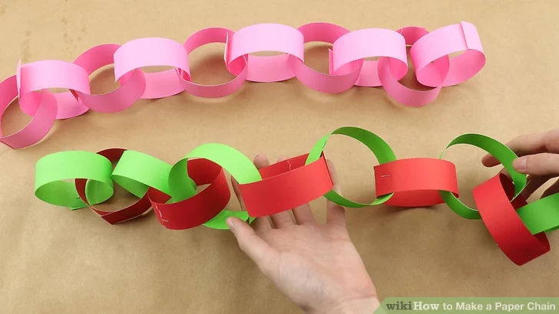
- Plan a family celebration-
  - Decide on a family celebration for the week. This could be a family indoor picnic, meal, dance etc. Ask your child to write invitations to family members to the party.
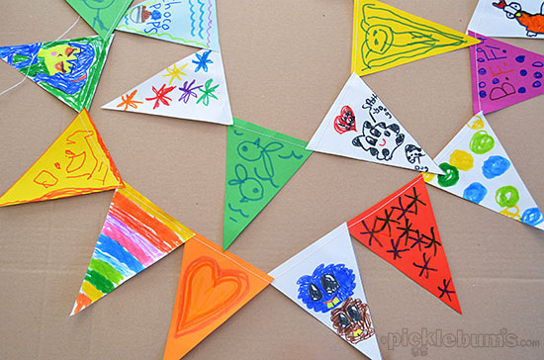
  - Create homemade decorations using coloured paper (If you do not have coloured paper at home, you could use old newspaper or wrapping paper) You could make paper chains or bunting
  - Plan a menu for the party and make the food together.

- Discover religious celebrations-
  - Watch the Let’s Celebrate video collection for Easter. Discuss the celebrations with your child. Did they celebrate Easter? Which of the events did they take part in?

  - Watch the Let’s Celebrate video collection for Eid-al-Fitr. Discuss the celebrations with your child. Did they celebrate Eid-al-Fitr? How did they celebrate? Are there any similarities and differences between the celebrations they saw in the Easter videos?

  - Look through the range of videos available on Cbeebies and watch together. Discuss who celebrates the event and any similarities and differences with celebrations your child has taken part in.
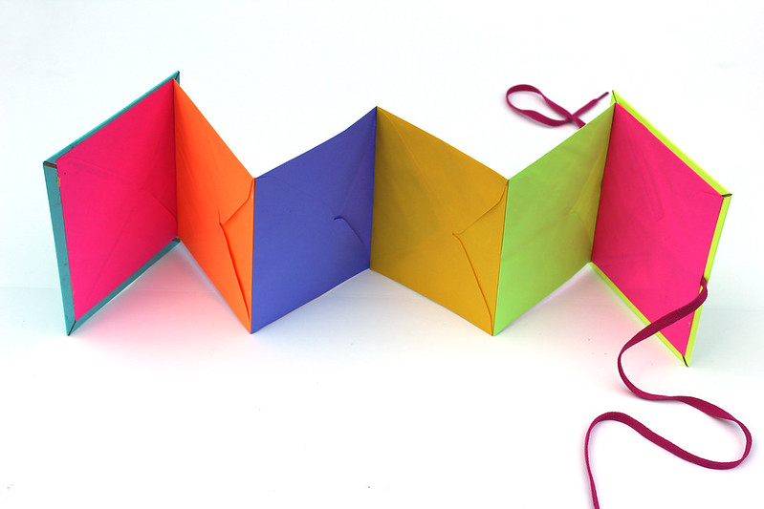
- Birthdays-
  - Talk to your child about when they were born. Look at photographs of the day they were born, if you have them available. Do they know the date of their birthday? Support your child to create an all about me folding book (as pictured) with their birth date, current age and anything else they think is important for people to know about them.
Additional learning resources parents may wish to engage with
Classroom Secrets Learning Packs - These packs are split into different year groups and include activities linked to reading, writing, maths and practical ideas you can do around the home.
Twinkl - to access these resources click on the link and sign up using your own email address and creating your own password. Use the offer code UKTWINKLHELPS.
Headteacherchat - This is a blog that has links to various learning platforms. Lots of these are free to access.
#TheLearningProjects

