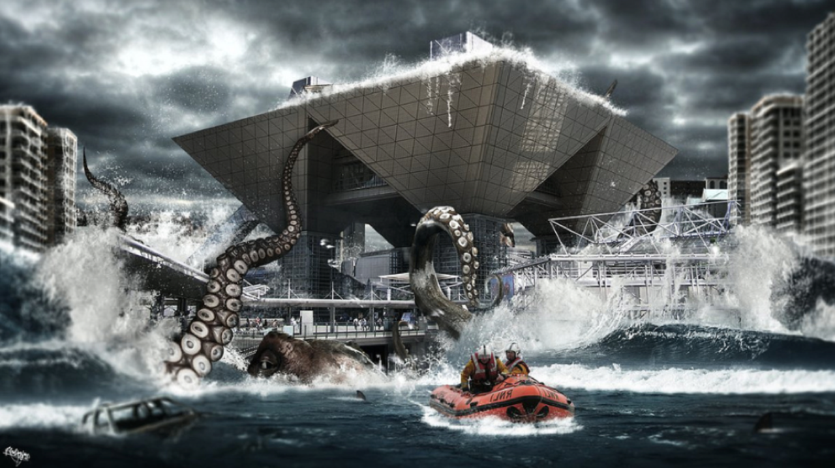
Use the image to complete the story.

It came from the sea, calmly at first. An enormous, slithering tentacle slowly oozing its way over the top of the sea wall, exploring the metal and concrete shapes with suckers the size of your front door.
Then, as more and more people came, and shrieks and cries of alarm filled the air, the creature became angry. All hell broke loose…
In an almighty tangle of limbs and water and buildings and people, the beast came violently exploding out of the frothing water. The normally sturdy metal supports of the buildings groaned under the extreme weight of the gigantic tentacles crushing them. Panic. Complete panic set in.
But where had the creature come from? What did it want? How could anybody stop it?
There wasn’t time for people to think. Only to run…

