Find half of each set of stamps.

A) | 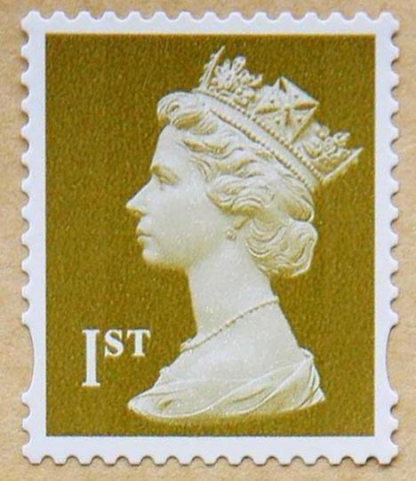
B)
C)

D)

A)

- Find half of these numbers.

- 14
- 18
- 24
- 28
- 34
- 36
- 40
- 46
- 42
- 54

- Find a quarter of these numbers.
- 12
- 20
- 24
- 32
- 40
- 48

- Find a third of these numbers.
- 18
- 27
- 36
- 21
- 42
- 48

- Find a quarter of these numbers.
- 12
- 20
- 24
- 32
- 40
- 48

- What fraction of each of these numbers can you find? Write all the possibilities.

- 15
- 20
- 24
- 27
- 32
- 40
- Write three top tips for finding fractions of numbers.

