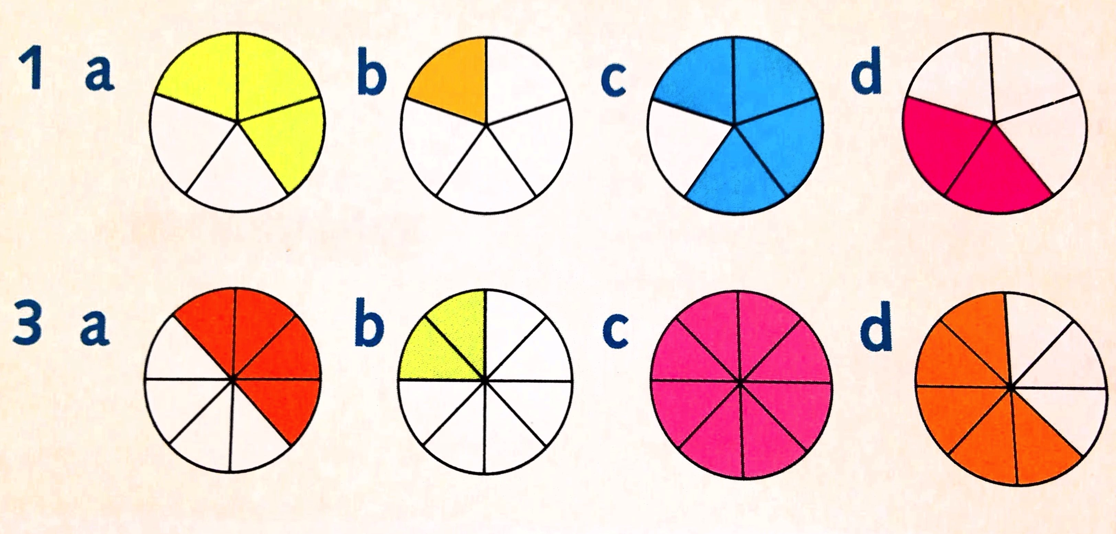
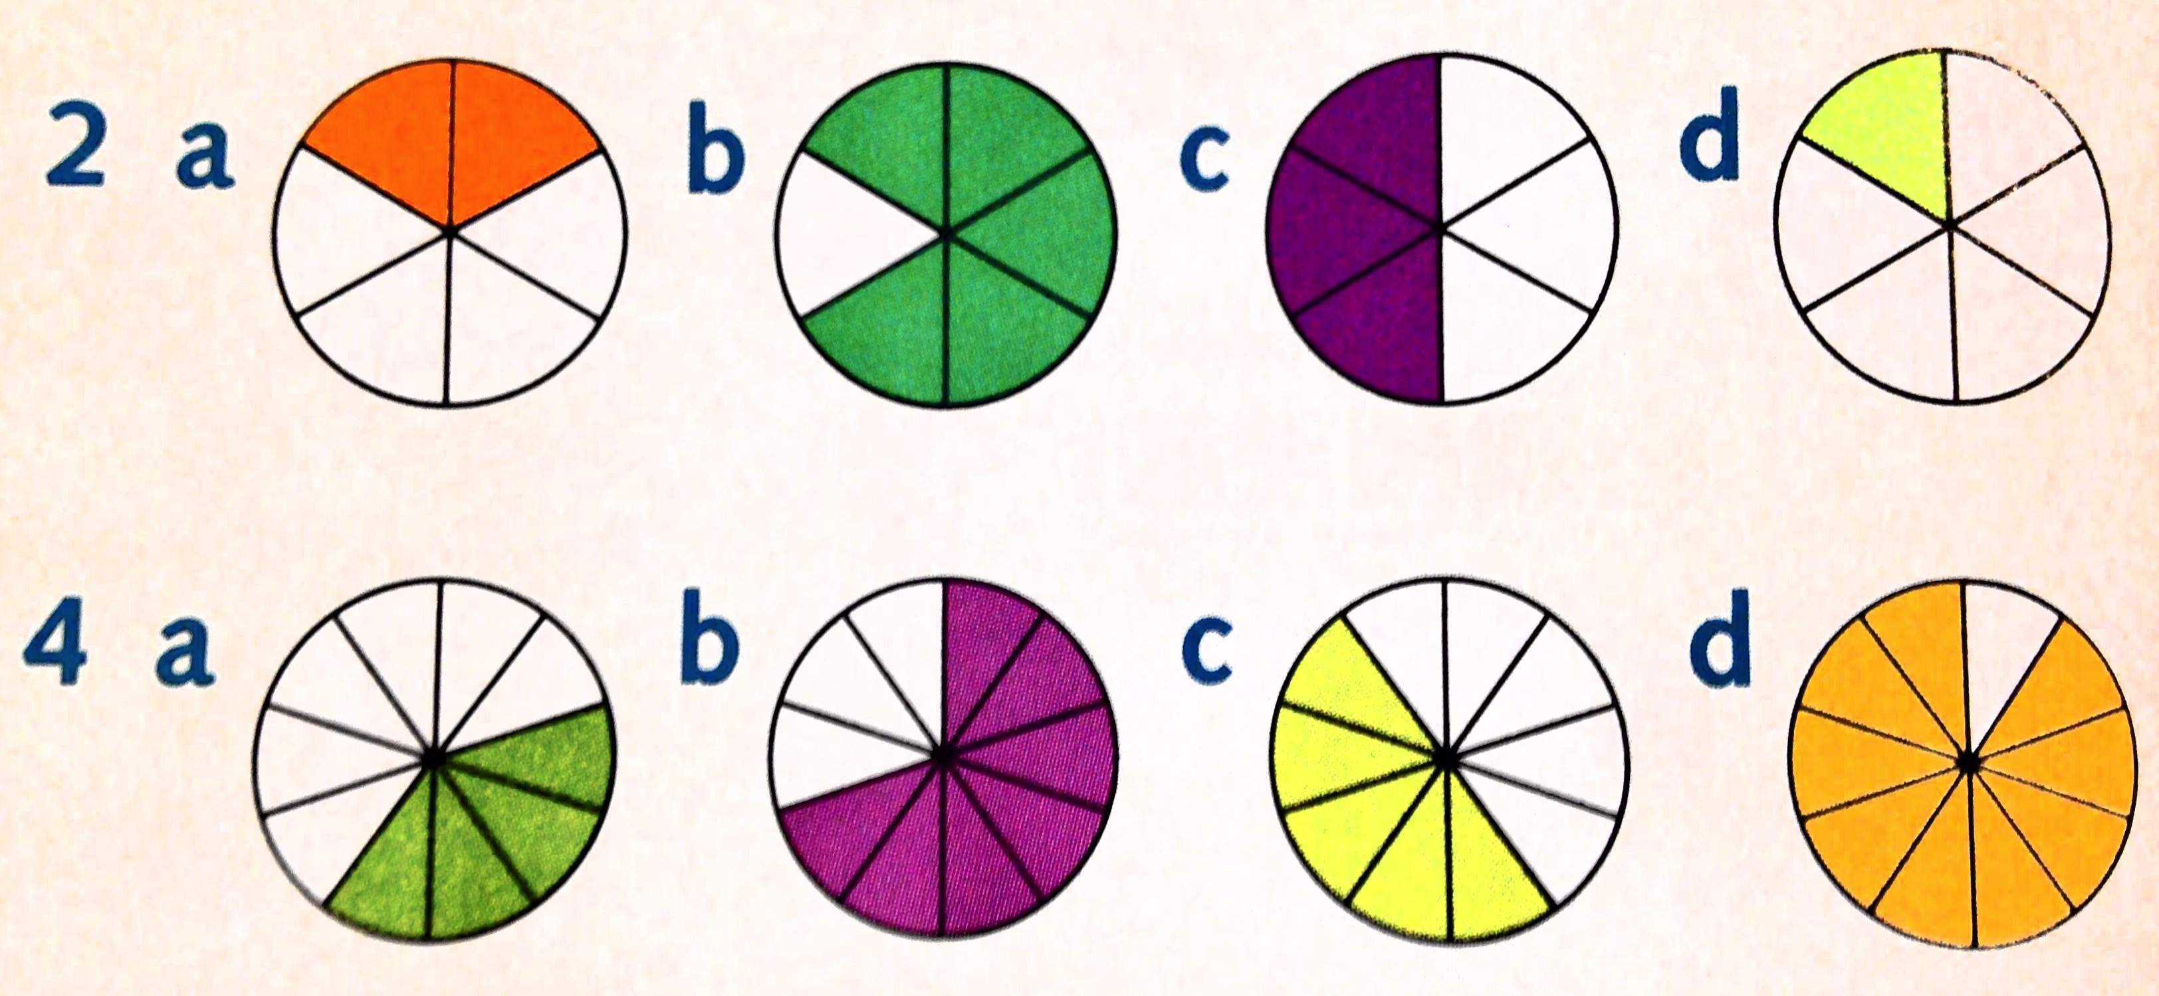
1. Write the fraction that describes the coloured part of each circle.

5. Now put each set of fractions in order, smallest to largest.

6. Order each set of fractions, smallest to largest.
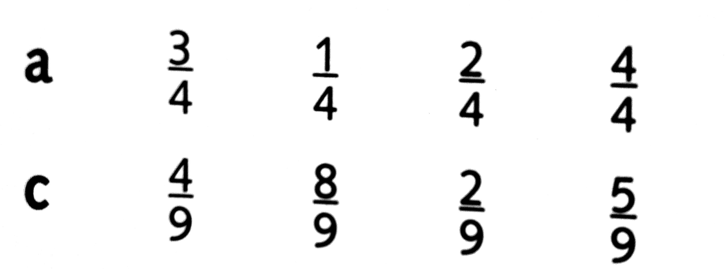
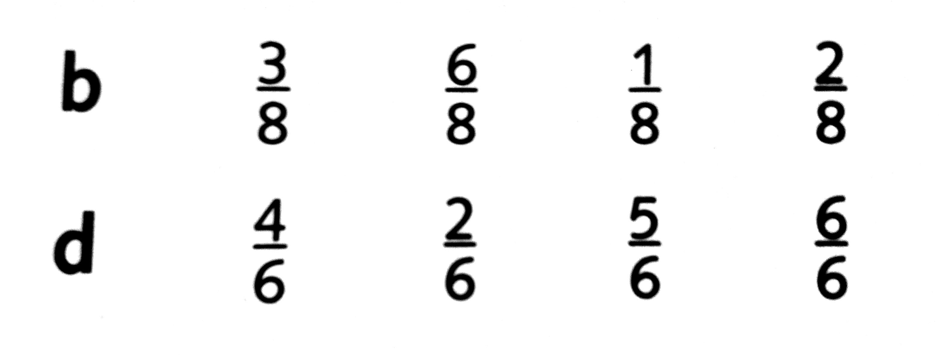
7. Would you rather have 2/8 or 5/8 of a chocolate cake? Explain why.

8. Order each set of fractions, smallest to largest.
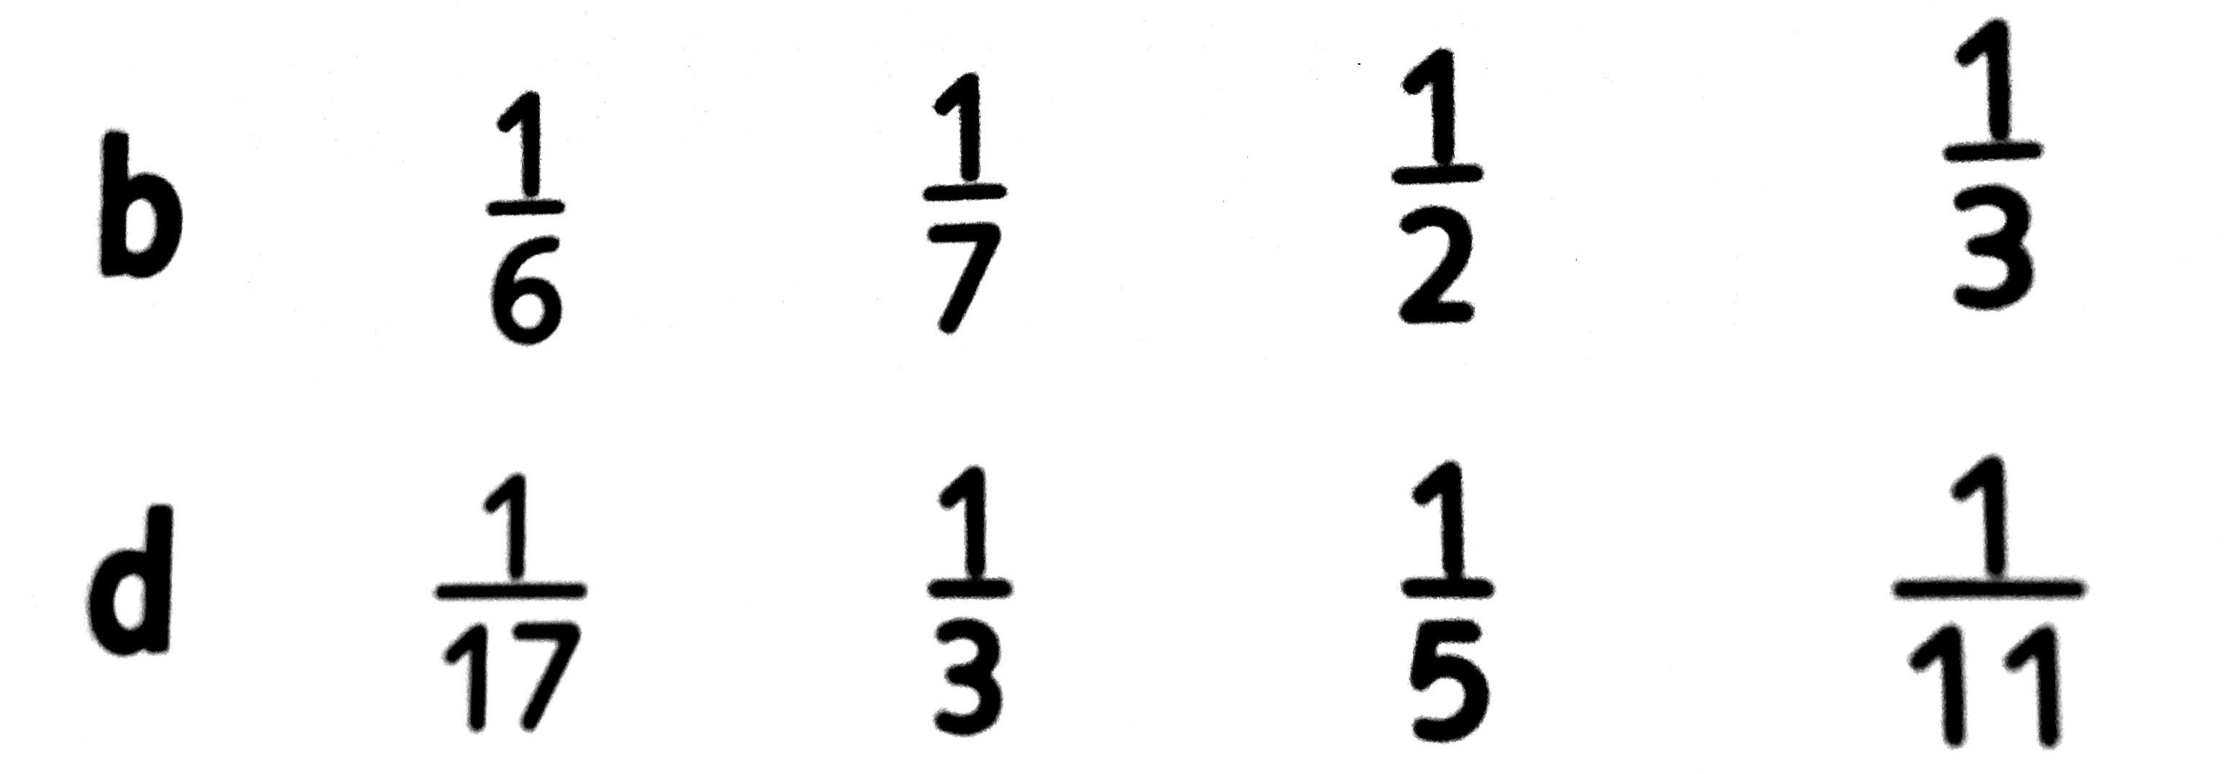
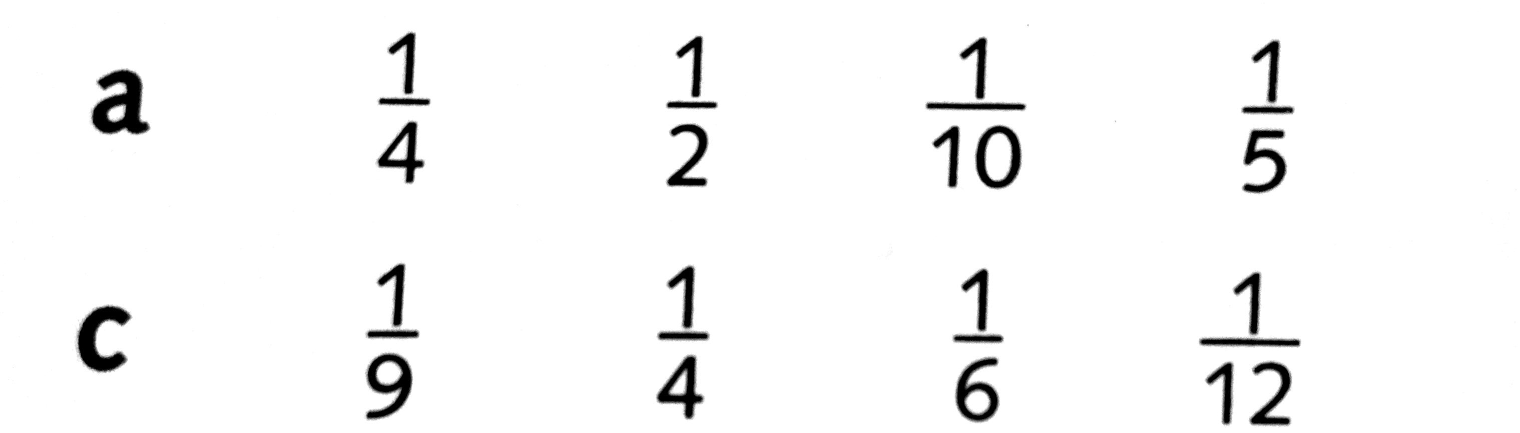

9. Write instructions for ordering fractions with different denominators.

10. What does the denominator tell us about the fraction?

