Now you have practised how to work out length and perimeter, have a go at these reasoning problems.

Q1.
On the line below, mark the point that is 6.7 centimetres from A.

Q2.

Kate has a piece of ribbon one metre long.
She cuts off 30 centimetres.

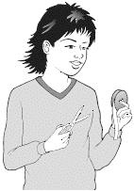
How many centimetres of ribbon are left?

Q3.

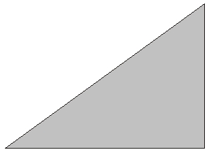
Measure accurately the length of the shortest side of this triangle. Write your answer in centimetres.

Q4.
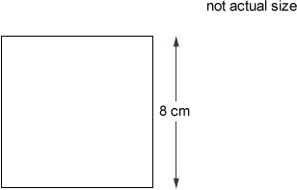
Calculate the perimeter of this square.
Q5.
Rose made shapes using four squares.
She calculated the perimeter of each shape.
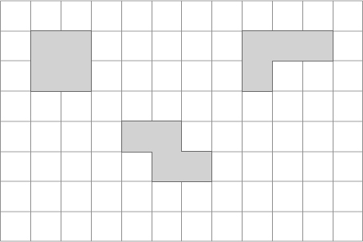
What is the length of the shortest perimeter?

What is the length of the longest perimeter?

