READING COMPREHENSION

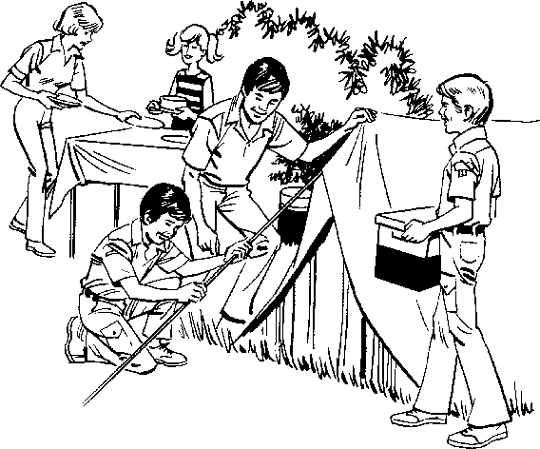

Sam is fourteen years old and joined the scouts as a Beaver when he was seven because his best friend David had joined and Sam wanted to go as well. His meeting is held in the local church and is on a Thursday, starting at six and ending at half past seven. Sam has made many friends going to Scouts, from lots of other schools which he many never have met if he hadn’t gone to Scouts.

He has learnt many skills at Scouts which have helped him grow up and become a better person, it is more than just learning how to tie knots, it is an adventure. Sam has learnt how to put up a tent, has hiked in the mountains, has become a leader which will help him when he leaves school and goes to University, and it isn’t all about sport. His friend David loves football, and plays for the county, but prefers to canoe up rivers, which he also learnt to do at Scouts. In two years Sam is planning to go Scouting abroad with Globetrekker, the plan is to go camping in Sweden, and canoe up the many rivers there. Sam does not plan to leave Scouts but wants to become a leader himself, helping other young boys to do all the things that he has been able to do. Sam is a Scout and is proud of it.

1. How old was Sam when he joined Scouts?

_______________________________________________________

1. Why did Sam join Scouts?

_______________________________________________________

1. Name two skills which Sam has learnt?

_________________________ and __________________________

1. Where does Sam plan to go in two years?

_______________________________________________________

1. What does he plan to do when he gets there?

_______________________________________________________

1. What is the name of the organization which helps Scouts go abroad?

_______________________________________________________

1. Scouting is both for boys and girls, would you be tempted, give reasons?

_______________________________________________________