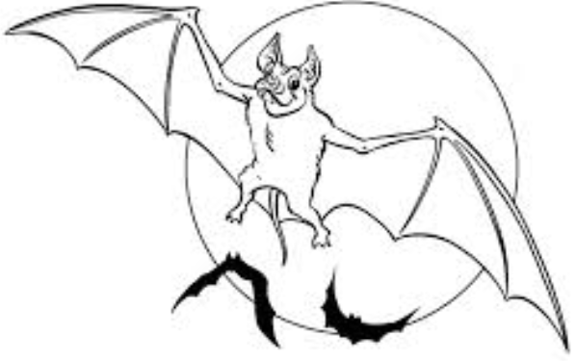

Bats are not blind, but no animal can see in complete darkness. Since many kinds of bats hunt insects at night, they have an additional trick called echolocation for finding their way in the dark. The bat uses its mouth to create sounds that bounce off nearby objects, such as a moth, as the sound comes back to the bat’s ears it can tell where the object is. Using echolocation, the bat can find its prey and snatch it in midair. Most are insectivorous and hunt their prey by chasing it down while flying. These insects are detected by the bats echolocation.

READING COMPREHENSION

INSECTS : aerial hawkers Most bats eat insects which they hunt by chasing them down while flying. They find the insects in the dark by a form of radar, as they push sound out, it bounces off objects and back to the bat. They can then work out the direction of the prey and how far away it is.

INSECTS: ground feeders Some insect eating bats can land on the ground and chase insects that live in leaf litter or similar places. These can eat big insects like scorpions and seem to be immune from their sting.

NECTAR: Not only butterflies and bees drink nectar from flowers, some bats do too. These bats have long tongues which help them to lick the nectar deep inside the flowers.

POLLEN: It is not only bees which pollinate plants, some bats also do this. These bats have brushes on their tongue which brushes the pollen which they then take to another plant and are important for pollinating mangoes and bananas.

1. What does aerial hawker mean?

______________________________________________________________

1. How does a bat’s radar work?

____________________________________________________________________________________________________________________________

1. Name four different types of food bats eat.

______________ / ______________ / _______________ / ______________

1. Are bats blind?

______________________________________________________________

1. How does a bat ‘pollinate’ a flower?

__________________________________________________________________________________________________________________________________________________________________________________________

|  |  |
| --- | --- |
| INSECTS - ground feeders | Some insect eating bats can land on the ground and chase insects that live in leaf litter or similar places. One of these bats called the Pallid Bat, from USA, loves to eat scorpions and large centipedes. These bats seem to be immune to the stings of scorpions and the poisonous bits of big centipedes. Pallid Bats always have scars on their wing membranes from bites and stings. |
| http://www.batdetective.com/nectar-feederT.jpg | NECTAR | Not only butterflies and bees drink nectar from flowers. The Australian Southern Blossom Bat, the smallest fruit bat at only 3 inches, comes to flowers, at night, to drink nectar. The plants that bats come to, only release their nectar at night along with a strong scent for them to home in on. Nectar feeding bats have very long tongues to enable them to get something to eat from nectarines deep inside flowers. |
| http://www.batdetective.com/pollen-feederT.jpg | POLLEN | This group of bats is very important for pollinating many of the exotic fruits we eat. Mangoes and bananas are two of the better-known fruits. Pollen bats have tongues that are adapted to feeding on pollen by having 'brushes' to collect the grains. |

|  |  |
| --- | --- |
| INSECTS - ground feeders | Some insect eating bats can land on the ground and chase insects that live in leaf litter or similar places. One of these bats called the Pallid Bat, from USA, loves to eat scorpions and large centipedes. These bats seem to be immune to the stings of scorpions and the poisonous bits of big centipedes. Pallid Bats always have scars on their wing membranes from bites and stings. |
| http://www.batdetective.com/nectar-feederT.jpg | NECTAR | Not only butterflies and bees drink nectar from flowers. The Australian Southern Blossom Bat, the smallest fruit bat at only 3 inches, comes to flowers, at night, to drink nectar. The plants that bats come to, only release their nectar at night along with a strong scent for them to home in on. Nectar feeding bats have very long tongues to enable them to get something to eat from nectarines deep inside flowers. |
| http://www.batdetective.com/pollen-feederT.jpg | POLLEN | This group of bats is very important for pollinating many of the exotic fruits we eat. Mangoes and bananas are two of the better-known fruits. Pollen bats have tongues that are adapted to feeding on pollen by having 'brushes' to collect the grains. |