Science

For science this week, children can choose from a range of interesting experiments by visiting this website: http://www.sciencefun.org/kidszone/experiments/
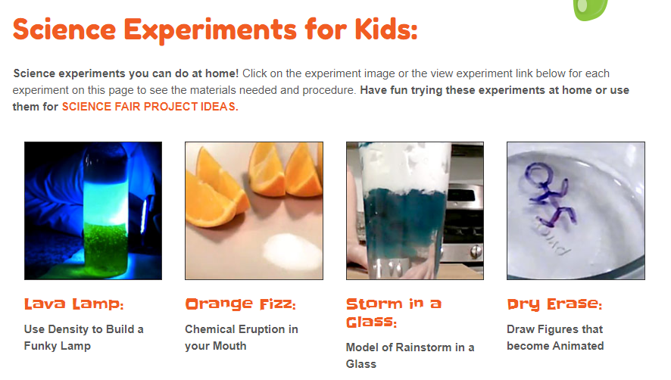
It would be great to see diagrams of what you do and a description of the experiment and how it went.
If you do more than one, which one was your favourite and why?

