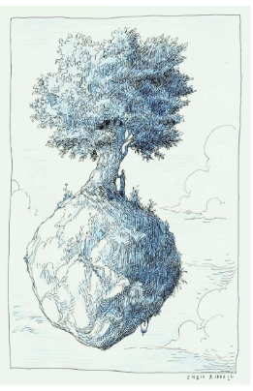
Picture taken from ‘The book of hopes.’
Day One- Setting the scene and introducing characters.

You can make up your own title for this one
WALT-Write effective sentences for a story.
WILF-
- Descriptive words for characters and setting.
- Senses.
- Alliteration.

Day Two- Something exciting happens!
WILF-
- Action sentences.
- Parenthesis.
- Simile and metaphor.

Day Three- A problem. What could go wrong?
WILF-
- Show not tell.
- Short sentences.
- Emotions and feelings.

