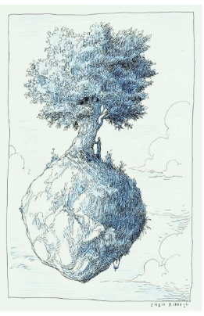
Day Four-The problem is resolved.
WALT-Write effective sentences for a story.
WILF-
- Fronted adverbials.
- Complex sentence.
- Onomatopoeia.

Day Five- The ending.
Happy, sad or cliff-hanger (maybe literally!)…how will it end?

