Use the image below to complete the story.

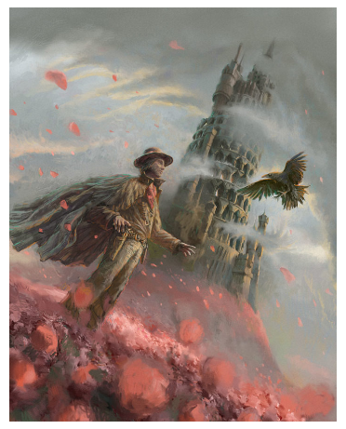

The wind whirled round and round, gathering speed at every turn. The man stood firm in the field of flowers, awaiting the return of his trusted companion. This was an important mission and he had to know how to enter the tower. It was the only way to unlock the secret of his family.

