Use the image to complete the story and answer the questions.
- Can you continue the story of George’s ship coming to life?
- What will he do with the ship now that it has magically appeared?
- ‘He loved this moment, seeing his creations come to life’. The story starter refers to George’s creations in the plural. What does this tell you?
- What other drawings might George have done in the past? Where are they now?
- If you could draw anything (knowing it would come to life) what would you draw?
- What was George’s magic word?
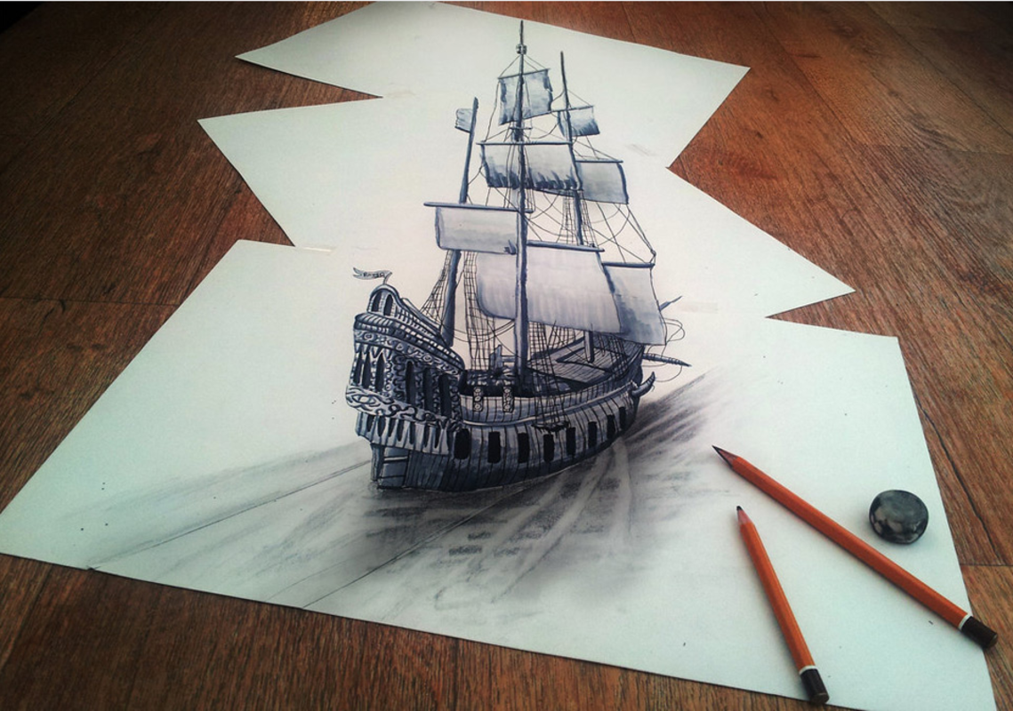

He had been working on the drawing for hours, locked away in complete silence in his study, letting his imagination run wild. The only sound that could be heard was the soothing scratching of his pencil on the textured paper.
When he had finished, George stood up and took a step back, proud of the work he had done. He was an extraordinary artist, more extraordinary than any other artist in the entire world!
As George spoke the magic word, the ship’s sails started to flutter as if a strong breeze blew through the room. He loved this moment, seeing his creations come to life...

