Use the image to complete the story and answer the questions.
- Who is the girl in the story?
- Why might she have been standing there for hours?
- Why might the girl be trembling?
- Where is the girl standing?
- What do you think is happening in the picture?
- How long is the split that seems to be appearing on the Earth’s surface?
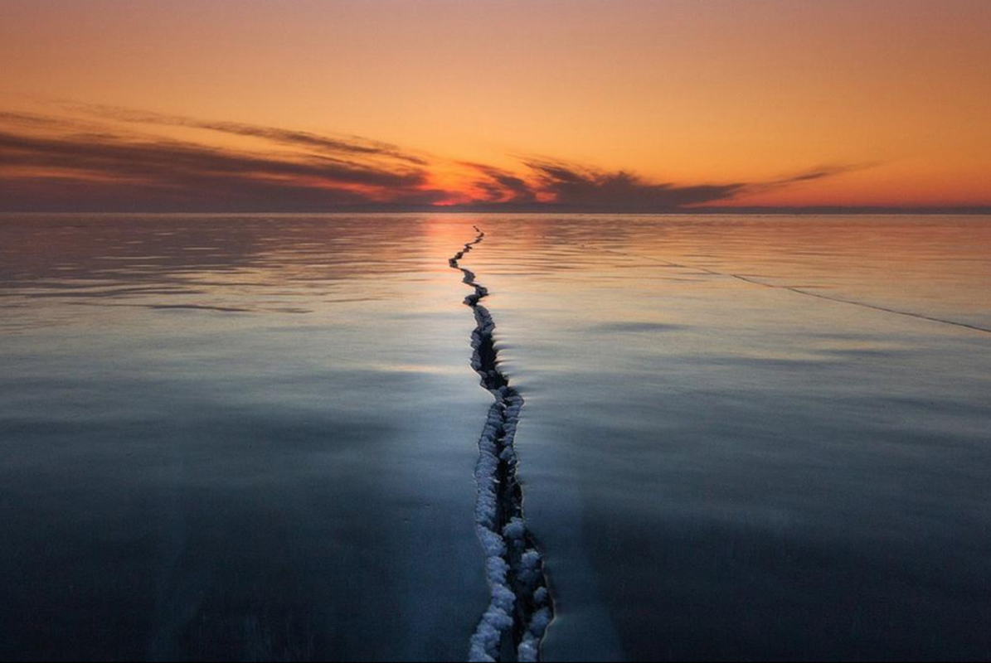
She had been standing there for hours, surrounded by ice.
As the sun peeped its head over the distant mountains on the horizon, an orange and yellow hue filled the sky. The warmth of the sun was a gesture of kindness to her frozen hands, which she clasped together in front of her trembling body.
It was then that she heard it… Crack! It was as if the world in front of her was breaking in two...

