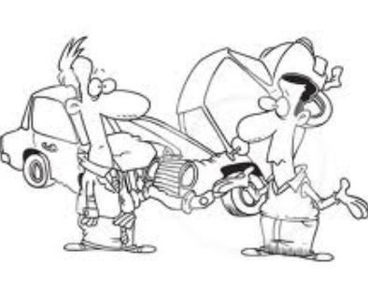

**THE ACCIDENT**

As he went through the lights another car came from a road to his left and hit him in the side. Crash! No one was hurt but the other driver was very angry.

“You idiot” he shouted at Tom “Why did you go through a red light?”

Tom said that he hadn’t and that the light had been amber – but he felt embarrassed. Perhaps the light had turned red and he thought it was probably his fault, but he wouldn’t admit it. A lady who had been crossing the road said she had seen the whole thing. Oh dear – what a day?

1. What time did Tom leave the house?

_________________________________________________

1. Where was Tom going?

_________________________________________________

1. Where does Tom work?

_________________________________________________

1. Why did Tom speed up?

_________________________________________________

1. Why was Tom embarrassed?

_________________________________________________

1. Whose fault was the accident?

_________________________________________________

1. Why did Tom say ‘Oh dear?’

__________________________________________________

Tom was late for work when the accident happened. He left his house at half past eight as he needed to start work at nine. John works in a shop. He saw the light turn amber and knew that he should stop, but he tried to drive faster so that he could get through the lights before they turned to red.