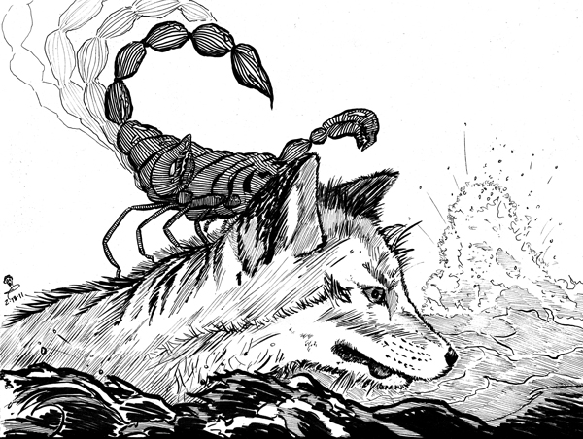
The fox and the scorpion
The forest was on fire and all the
animals swam across the river to
escape the fire.
The scorpion could not swim
and begged the fox to help
him.
“Please take me across the river on your back – or I will die.”
“I am not a fool” said the fox “you will sting me and I will drown”
“No” replied the scorpion “I promise that if you help me – I will not sting you – after all, if you drown then so will I”
“Okay” the fox agreed, and the scorpion climbed on his back.
Halfway across the river, at the deepest part – the scorpion stung the fox.
“Why did you do that” the fox shouted.
“I just couldn’t help it” cried the fox as they both drowned. “It’s just my nature!”

- Why were the animals swimming across the river?

- Why did the scorpion ask for help?

- Why was the fox worried?

- How did the scorpion get the fox to help him?

Discuss: What is the real meaning of this story?

