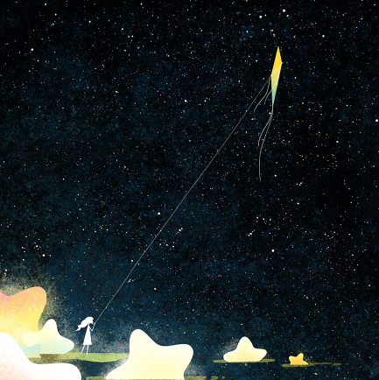
Star kite.
Day One-
WALT-Write effective sentences for a story.
Every night I would see her…
WILF-
- Expanded noun phrase.
- Verbs for movement.
- Senses sentences.

Day Two-
One night something incredible happened…
WILF-
- Use emotions.
- Use short sentences- subject/verb.
- Use show not tell.
Day Three-
The most wonderful sight I have ever seen appeared before me…
WILF-
- Thought/ imagining sentence.
- Relative clause.
- Simile.
Day Four-
The more I watched, the more…
- The more, the more.
- ‘If’ sentence.
- Begin with an adverb.
Day Five-
Write an ending to your story

