The Writer
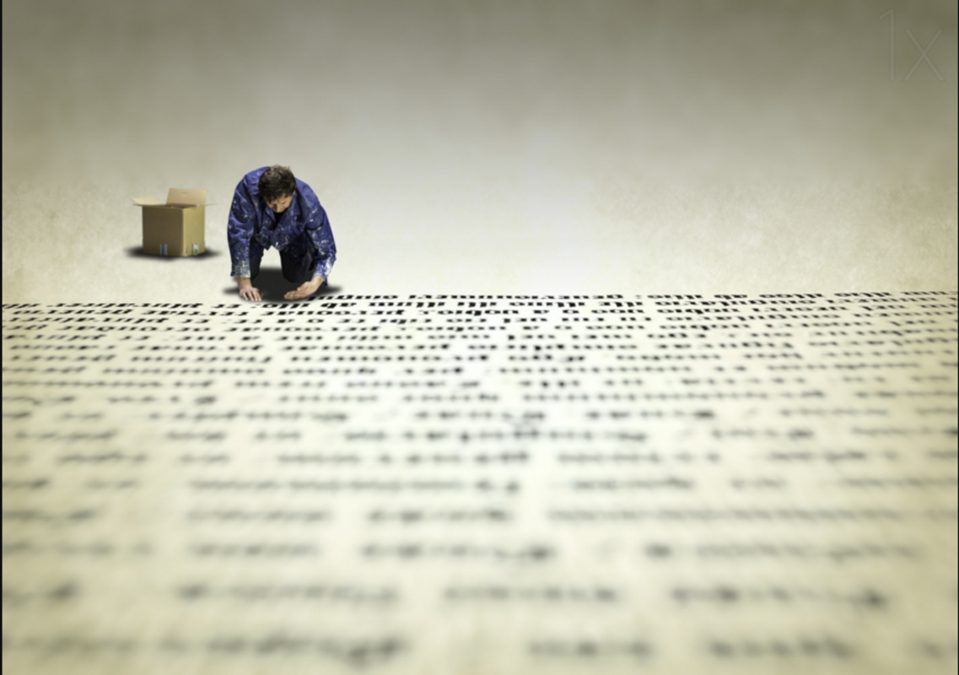

The process took a great deal of time and effort, but doesn’t anything that’s important to us?
Will gently moved the back of his hand across the parchment. He loved the feeling of it against his skin; it was smooth and silky like the fresh water of a spring cascading over his fingers.
Feeling relaxed, Will was a master of his trade. Words came as easily to him as song to a nightingale. The whole experience of writing filled his heart with pure joy, but at the same time Will knew he had to concentrate; he had an important job to do…

Questions
- Who is Will? Why do you think he enjoys writing so much?
- Is he extremely small, or is the book he is writing very large?
- What does ‘he had an important job to do’ mean? Why is he writing? Is he writing for somebody?
- What type of writing do you think it is?
- What is inside the box?
- Imagine you could see the rest of the room Will is in. Can you describe what it might contain?

